CYBER AWARENESS MONTH · ICS / OT / IoT
Cyber-Physical “Spot the Issue” Catalog
A field companion to the corporate-office awareness scene — for operational technology. 23 field scenarios across manufacturing, oil & gas, electric, natural gas, maritime, buildings & facilities, water & wastewater, healthcare, aviation and food retail, each seeded with cyber, safety and good-practice findings and flagged to IEC 62443-3-3, IEC 62443-4-2, the Secure PLC Coding Top 20 and ISA-TR84.00.09 v3.
How to use it
1. Each scene hides eight numbered findings. Learners spot the numbered markers and call out what looks wrong.
2. The table under each scene is the answer key — what to look for, the finding type, and the standards it maps to.
3. Run it as a quiz: hold the key back and let the group find all eight, or reveal one item at a time.
Finding type
● Cyber ● Safety / cyber-physical ● Good practice
Standards flagged
3-3 IEC 62443-3-3 (system security requirements)
4-2 IEC 62443-4-2 (component security requirements)
PLC Secure PLC Coding Practices – Top 20
84.09 ISA-TR84.00.09 v3 (cybersecurity & the functional-safety lifecycle)
Scenarios in this catalog
1. Manufacturing — Pharma / Biotech Manufacturing Plant
2. Oil & Gas — Oil & Gas — Upstream Wellpad & Drilling
3. Oil & Gas — Oil & Gas — Midstream Pump Station & Tank Farm
4. Oil & Gas — Oil & Gas — Downstream Refinery & Control Room
5. Oil & Gas — Oil & Gas — Offshore Platform & Helicopter Transfer
6. Electric — Electric — Transmission Substation
7. Electric — Electric — Smart Meters & Distribution Automation
8. Natural Gas — Natural Gas — Farm Tap, Pipeline Station & Compression
9. Natural Gas — Natural Gas — LNG Terminal
10. Maritime — Maritime — Vessel Bridge & Engine Room
11. Maritime — Maritime — Port & Container Terminal
12. Buildings & Facilities — Data Center — Cooling & Mechanical Plant
13. Buildings & Facilities — Buildings — Automation & Boiler Plant
14. Buildings & Facilities — Buildings — Fire & Life Safety Systems
15. Buildings & Facilities — Buildings — Physical Access Control & Security
16. Water & Wastewater — Water & Wastewater — Surface Water Treatment Plant
17. Water & Wastewater — Water & Wastewater — Remote Sewer Lift Station
18. Healthcare — Healthcare — Hospital Facility Control Systems
19. Healthcare — Healthcare — ER Medical Device Systems
20. Aviation — Aviation — Airfield Lighting Control System
21. Aviation — Aviation — Baggage Handling Control System
22. Food Retail — Food Retail — Grocery Refrigeration & Cooling
23. Food Retail — Food Retail — Grocery Logistics & Facilities

On the standard IDs. IEC 62443-3-3 (SR), 62443-4-2 (CR/EDR/HDR/NDR) and the Secure PLC Coding Top 20 (#) are cited by exact requirement/item ID and name. ISA-TR84.00.09 v3 items are flagged by their security-lifecycle element and the IEC 61511 phase they sit in (Analysis / Realization / Operation); confirm exact clause numbers against your controlled copy of v3. Finding types and standard mappings are teaching aids, not a compliance assessment.
MANUFACTURING Pharma / Biotech Manufacturing Plant
Bioreactor cleanroom suite — DCS/MES, serialization line, batch records
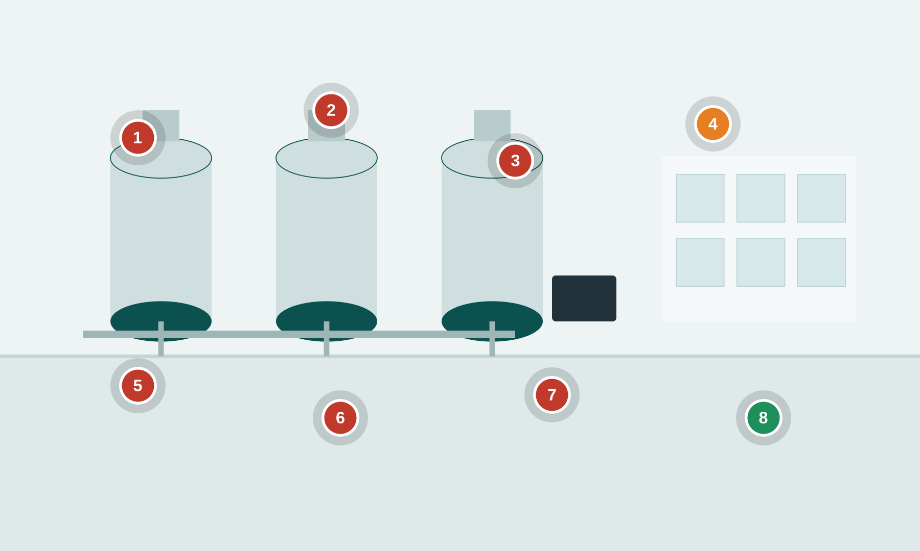
Numbered markers = planted findings. ● cyber ● safety ● good practice
Setting. A GMP bioreactor and cleanroom suite. Operators run a batch from HMIs on a process DCS; an MES pulls recipes and writes electronic batch records; a serialization/packaging line runs downstream; a bioreactor SIS protects against over-pressure and runaway reactions.
Key OT/IoT assets: Bioreactor / fermenter PLCs · Process DCS + operator HMIs · MES & OT historian · Serialization / packaging line PLC · Bioreactor SIS (over-pressure trip) · CIP (clean-in-place) skid · Engineering workstation (EWS)
People & roles: Batch/process operator · Manufacturing / automation engineer · QA (batch release) · Contract validation engineer · Maintenance technician
Processes: Batch execution & recipe download · Change control / MOC · Data historian & batch review · Cleaning validation (CIP) · SIS proof testing
What to look for
# | What to look for | Standards flagged — requirement ID & name
1 | Shared HMI login Cyber  HMI signed in with a shared 'operator' account; no per-user identity, so batch actions can't be attributed. | 3-3 SR 1.1 Human user identification and authentication  4-2 CR 1.1 Human user identification and authentication  84.09 Operation SIS access control and independence from the BPCS
2 | Recipe editable at HMI Cyber  Batch/recipe parameters can be changed directly at the HMI with no authorization step or second check. | 3-3 SR 2.1 Authorization enforcement  3-3 SR 3.4 Software and information integrity  PLC #8 Validate HMI input variables at the PLC level, not only at the HMI
3 | Laptop + USB on DCS Cyber  Unmanaged engineering laptop and USB drive plugged straight into the control cabinet / engineering port. | 3-3 SR 2.3 Use control for portable and mobile devices  4-2 CR 2.13 Use of physical diagnostic and test interfaces  3-3 SR 3.2 Malicious code protection
4 | SIS trip bypassed Safety  Bioreactor over-pressure trip left in BYPASS with no management-of-change record. | 84.09 Operation Bypass / override management for the SIS  PLC #2 Track operating modes  PLC #15 Define a safe process state in case of a PLC restart
5 | Flat MES/OT network Cyber  MES/IT and bioreactor PLCs share one flat VLAN — no zone boundary between business and process. | 3-3 SR 5.1 Network segmentation  3-3 SR 5.2 Zone boundary protection  4-2 CR 5.1 Network segmentation
6 | Default vendor password Cyber  PLC/HMI still on the default vendor credential printed on a sticky note. | 3-3 SR 1.5 Authenticator management  3-3 SR 1.7 Strength of password-based authentication  4-2 CR 1.7 Strength of password-based authentication
7 | Historian export to USB Cyber  Contractor exports historian/batch data to a personal USB drive with no control on the data flow. | 3-3 SR 4.1 Information confidentiality  3-3 SR 5.3 General purpose person-to-person communication restrictions  3-3 SR 2.3 Use control for portable and mobile devices
8 | Signed serialization code Good practice  GOOD PRACTICE: serialization line PLC runs a checksum / integrity check on its program and alarms on change. | PLC #5 Use cryptographic and/or checksum integrity checks for PLC code  3-3 SR 3.4 Software and information integrity
Photoreal image-generation prompt
Feed this to your image tool to render a photoreal “spot-the-issue” base scene matching the corporate example.
Photorealistic wide-angle shot inside a pharmaceutical bioreactor cleanroom, stainless-steel fermenter tanks and piping, an operator in a white gown and hairnet at a large HMI touchscreen. Visible tells for a 'spot the cyber-physical issue' training scene: the HMI shows a shared login 'operator / operator', a yellow sticky note on the panel reads 'PLC pw: Vendor123', a red-tagged SIS bypass switch is flipped to BYPASS with an alarm banner 'HIGH PRESSURE TRIP INHIBITED', an engineering laptop is plugged into the control cabinet by a USB cable with a USB thumb drive next to it, an unlocked network switch cabinet with IT and OT cables mixed together, a whiteboard reading 'Recipe params – edit at HMI OK'. Bright clinical lighting, shallow depth of field, realistic industrial detail, no text overlays or annotations.
OIL & GAS Oil & Gas — Upstream Wellpad & Drilling
Remote wellpad — RTU/flow computer, wellhead ESD, drilling rig, cellular SCADA
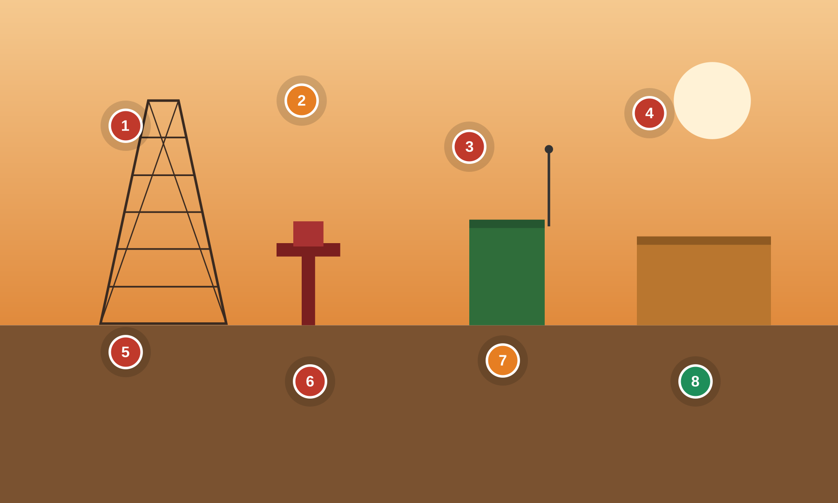
Numbered markers = planted findings. ● cyber ● safety ● good practice
Setting. A remote wellpad with a drilling rig doghouse. A field RTU / flow computer telemeters production over a cellular/satellite link to a central SCADA; the wellhead has an emergency shutdown (ESD) valve; H2S gas detection protects crews.
Key OT/IoT assets: Field RTU / flow computer · Wellhead ESD valve · Drilling rig control (doghouse) · Cellular / satellite SCADA modem · H2S gas detection · Custody metering · RTU enclosure / cabinet
People & roles: Pumper / lease operator · Drilling crew (driller, roughnecks) · SCADA / automation tech · Third-party service contractor · HSE / safety officer
Processes: Production telemetry & polling · Well control & ESD · Custody transfer measurement · Contractor turnaround work · Gas-detection alarm response
What to look for
# | What to look for | Standards flagged — requirement ID & name
1 | RTU exposed to internet Cyber  Cellular RTU reachable directly from the internet with no VPN; remote polling over an untrusted network. | 3-3 SR 1.13 Access via untrusted networks  3-3 SR 5.2 Zone boundary protection  4-2 CR 3.1 Communication integrity
2 | ESD in manual bypass Safety  Wellhead emergency-shutdown valve tagged into MANUAL BYPASS — safety function defeated. | 84.09 Operation Bypass / override management for the SIS  PLC #2 Track operating modes  PLC #15 Define a safe process state in case of a PLC restart
3 | Plaintext Modbus/SNMP Cyber  Flow computer polled over plaintext Modbus with default SNMP community; values readable and writable. | 3-3 SR 3.1 Communication integrity  3-3 SR 4.3 Use of cryptography  PLC #13 Disable unused / unneeded communication ports and protocols
4 | Contractor Wi-Fi laptop Cyber  Service contractor's unmanaged laptop joins the drilling control network over shared Wi-Fi. | 3-3 SR 2.3 Use control for portable and mobile devices  3-3 SR 1.6 Wireless access management  4-2 NDR 1.6 Wireless access management
5 | Shared creds on sticky note Cyber  Shared SCADA/radio credentials written on a sticky note in the doghouse. | 3-3 SR 1.5 Authenticator management  3-3 SR 1.7 Strength of password-based authentication  3-3 SR 1.1 Human user identification and authentication
6 | Open RTU cabinet Cyber  RTU enclosure padlock open and door ajar; controller and diagnostic port physically exposed. | 4-2 EDR 3.11 Physical tamper resistance and detection  4-2 CR 2.13 Use of physical diagnostic and test interfaces
7 | H2S detector disabled Safety  H2S gas detector bagged and alarm disabled — life-safety detection defeated. | PLC #20 Trap false negatives and false positives for critical alerts  PLC #7 Validate and alert for paired inputs / outputs  3-3 SR 6.2 Continuous monitoring
8 | Signed RTU firmware Good practice  GOOD PRACTICE: RTU fleet has an asset inventory with signed, verified firmware updates. | 3-3 SR 7.8 Control system component inventory  4-2 EDR 3.10 Support for updates  4-2 EDR 3.14 Integrity of the boot process
Photoreal image-generation prompt
Feed this to your image tool to render a photoreal “spot-the-issue” base scene matching the corporate example.
Photorealistic wide shot of a remote oil & gas wellpad at dusk, a drilling rig derrick and a wellhead 'Christmas tree' with red ESD valve, a small green metal RTU cabinet on a skid with a whip cellular antenna. Training tells: the RTU cabinet padlock hangs open and the door is ajar exposing a controller, a laptop sits on the cabinet connected by an Ethernet cable, a sticky note on the doghouse window reads 'SCADA radio: admin / admin', the wellhead ESD handwheel has a 'MANUAL BYPASS' tag zip-tied to it, an H2S gas detector head has a plastic bag over it and a red 'ALARM DISABLED' tag, a cellular router with a public IP label. Golden-hour lighting, dust, realistic oilfield detail, no text overlays or annotations.
OIL & GAS Oil & Gas — Midstream Pump Station & Tank Farm
Pipeline pump station — SCADA, mainline pumps, custody metering, tank overfill SIS
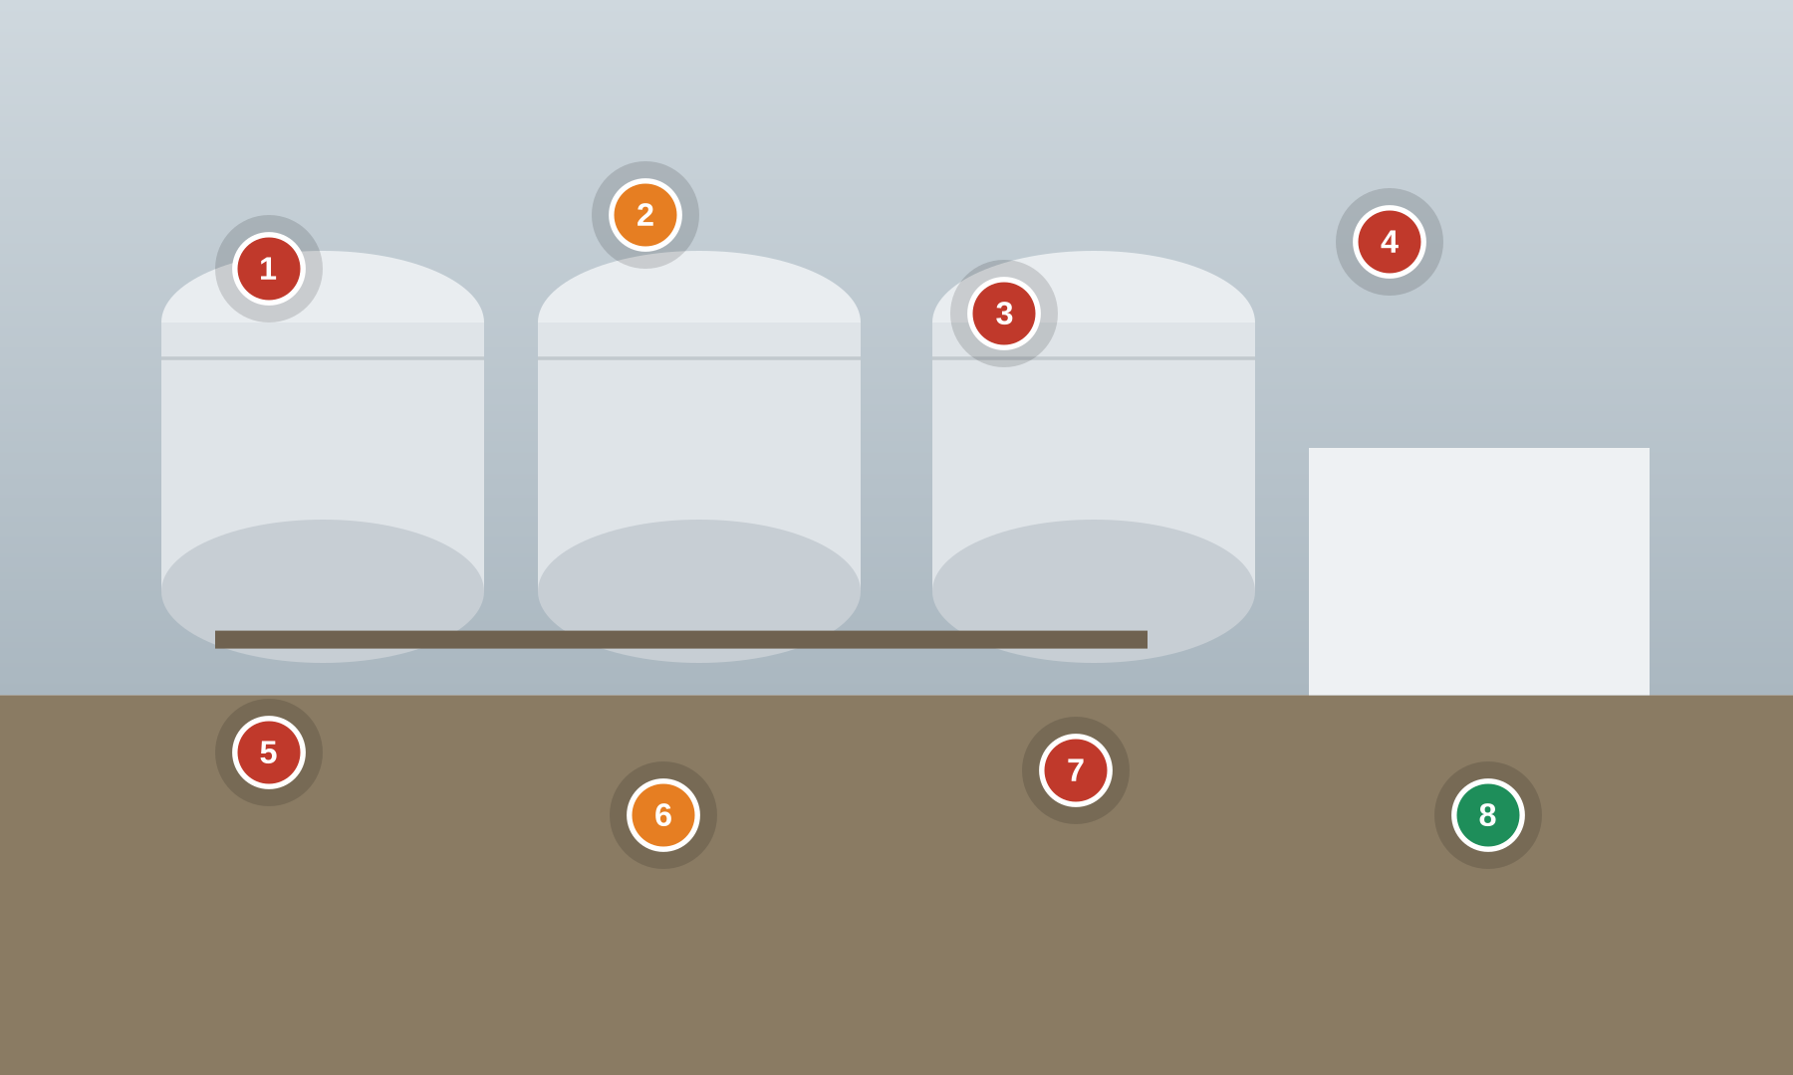
Numbered markers = planted findings. ● cyber ● safety ● good practice
Setting. A crude pipeline pump station and tank farm. SCADA drives mainline pump VFDs; custody metering measures transfers; storage tanks are protected by an overfill-prevention SIS and high-high level alarms; a leak-detection system watches the line.
Key OT/IoT assets: Pipeline SCADA + HMI server · Mainline pump VFD PLCs · Custody metering flow computers · Tank overfill SIS + high-high level · Leak-detection system · SCADA historian
People & roles: Pipeline controller (control center) · Station operator · Measurement technician · SCADA engineer · Vendor remote support
Processes: Pipeline batching & pump control · Tank gauging & overfill protection · Custody transfer measurement · Leak detection & response · Remote vendor support
What to look for
# | What to look for | Standards flagged — requirement ID & name
1 | Remote access open to internet Cyber  Pipeline SCADA reached via always-on TeamViewer/RDP exposed to the internet. | 3-3 SR 1.13 Access via untrusted networks  3-3 SR 2.6 Remote session termination  3-3 SR 5.2 Zone boundary protection
2 | Tank overfill trip inhibited Safety  Tank overfill-prevention SIS bypassed and high-high level alarm inhibited (Buncefield-type exposure). | 84.09 Operation Bypass / override management for the SIS  PLC #7 Validate and alert for paired inputs / outputs  PLC #12 Validate inputs based on physical plausibility
3 | Writable custody metering Cyber  Custody flow computer on unsecured Modbus; measurement values can be written/spoofed (fraud). | 3-3 SR 3.1 Communication integrity  3-3 SR 3.5 Input validation  PLC #14 Restrict third-party data interfaces
4 | Flat pump network Cyber  Mainline pump VFD PLCs share a flat network with the corporate historian; no segmentation. | 3-3 SR 5.1 Network segmentation  3-3 SR 5.2 Zone boundary protection  4-2 CR 5.1 Network segmentation
5 | Weak SCADA credentials Cyber  Shared SCADA HMI login on a weak password; no multi-factor for control access. | 3-3 SR 1.1 Human user identification and authentication  3-3 SR 1.7 Strength of password-based authentication  3-3 SR 1.5 Authenticator management
6 | Leak detection muted Safety  Leak-detection system left in maintenance/muted state — no alerting on a release. | PLC #2 Track operating modes  PLC #20 Trap false negatives and false positives for critical alerts  3-3 SR 6.2 Continuous monitoring
7 | Unpatched SCADA server Cyber  Windows SCADA server unpatched with no anti-malware / application allow-listing. | 3-3 SR 3.2 Malicious code protection  3-3 SR 7.6 Network and security configuration settings  4-2 HDR 3.2 Malicious code protection
8 | DMZ + one-way historian Good practice  GOOD PRACTICE: segmented DMZ with unidirectional replication of historian data to enterprise. | 3-3 SR 5.2 Zone boundary protection  3-3 SR 5.1 Network segmentation  3-3 SR 6.1 Audit log accessibility
Photoreal image-generation prompt
Feed this to your image tool to render a photoreal “spot-the-issue” base scene matching the corporate example.
Photorealistic wide shot of a crude-oil pipeline pump station and tank farm, large white storage tanks, mainline pump skids and pipe manifolds, a small control building. Training tells: a control room monitor shows a remote-access session labelled 'TeamViewer – always on', a tank gauge panel reads 'HIGH-HIGH LEVEL ALARM INHIBITED', a metering cabinet is open with a laptop wired in, a monitor shows 'Leak detection: MAINTENANCE / muted', a sticky note 'SCADA: operator / Password1', a network rack with IT and OT switches cabled together, an overflowing-looking tank near the top gauge. Overcast industrial lighting, realistic midstream detail, no text overlays or annotations.
OIL & GAS Oil & Gas — Downstream Refinery & Control Room
Refinery process unit — DCS control room, BPCS/SIS separation, furnace & flare
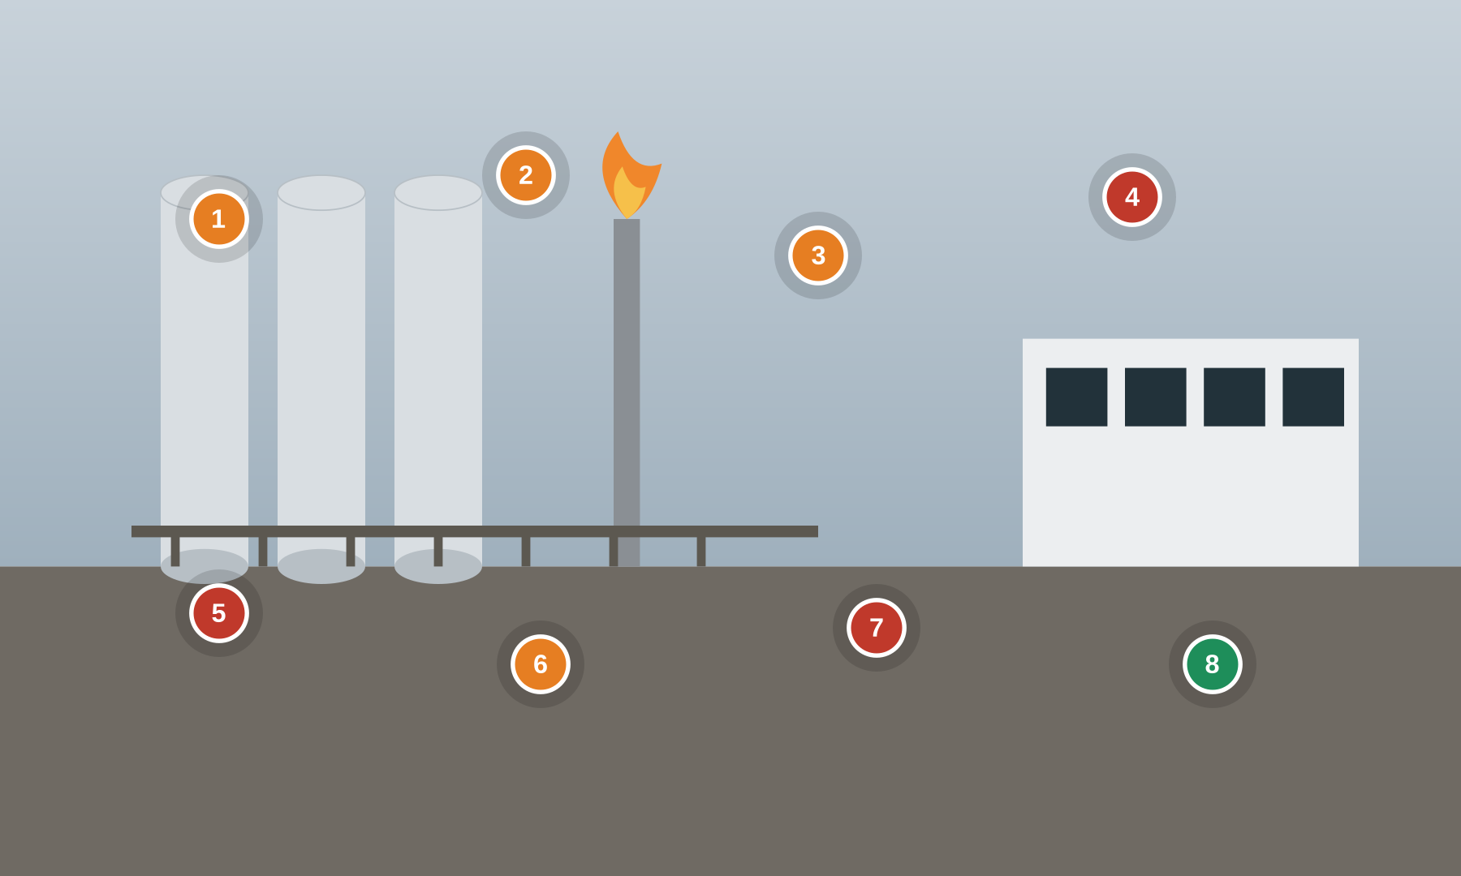
Numbered markers = planted findings. ● cyber ● safety ● good practice
Setting. A refinery process unit run from a central control room. A DCS (BPCS) drives the process; an independent SIS provides trips for furnaces, columns and compressors; operators work consoles under alarm management; vendors provide remote support.
Key OT/IoT assets: DCS / BPCS + operator consoles · Independent SIS + logic solver · SIS engineering workstation · Furnace / heater trips · Flare & relief system · Alarm management system
People & roles: Board operator · Outside operator · Process control engineer · Functional safety engineer · DCS/SIS vendor (remote)
Processes: Process control (BPCS) · Safety instrumented functions (SIS) · Alarm management & rationalization · Management of change · Vendor remote support
What to look for
# | What to look for | Standards flagged — requirement ID & name
1 | BPCS & SIS not separated Safety  BPCS and SIS share controllers/network with no independence between control and safety. | 84.09 Realization SIS zones and conduits (SIS as a separate zone)  3-3 SR 5.1 Network segmentation  3-3 SR 5.4 Application partitioning
2 | SIS key-switch in PROGRAM Safety  SIS logic-solver key-switch left in PROGRAM/REMOTE, allowing online logic changes. | PLC #2 Track operating modes  84.09 Realization Security verification & validation of the SIF  4-2 CR 2.13 Use of physical diagnostic and test interfaces
3 | Furnace trip forced Safety  Furnace/heater trip forced/bypassed on the DCS with no compensating measures. | 84.09 Operation Bypass / override management for the SIS  PLC #15 Define a safe process state in case of a PLC restart  3-3 SR 2.1 Authorization enforcement
4 | Unlocked shared console Cyber  Control-room console unlocked and unattended on a shared login; no session lock. | 3-3 SR 2.5 Session lock  3-3 SR 1.1 Human user identification and authentication  4-2 CR 2.5 Session lock
5 | Always-on vendor VPN Cyber  Vendor remote-support VPN left permanently connected with no time limit or monitoring. | 3-3 SR 1.13 Access via untrusted networks  3-3 SR 2.6 Remote session termination  4-2 NDR 5.2 Zone boundary protection
6 | Alarm flood / shelved alarms Safety  Alarm system flooded; nuisance alarms shelved, masking real safety alarms. | PLC #20 Trap false negatives and false positives for critical alerts  3-3 SR 6.2 Continuous monitoring  84.09 Operation Management of change (MOC) for SIS security
7 | USB IT->DCS transfer Cyber  USB drive used to move patches/graphics from IT into the DCS with no scanning. | 3-3 SR 2.3 Use control for portable and mobile devices  3-3 SR 3.2 Malicious code protection  3-3 SR 3.4 Software and information integrity
8 | Independent, locked SIS Good practice  GOOD PRACTICE: SIS is independent, in a locked cabinet, with MOC on every change. | 84.09 Operation Management of change (MOC) for SIS security  3-3 SR 7.6 Network and security configuration settings  4-2 EDR 3.11 Physical tamper resistance and detection
Photoreal image-generation prompt
Feed this to your image tool to render a photoreal “spot-the-issue” base scene matching the corporate example.
Photorealistic wide shot of a refinery central control room, curved wall of DCS operator consoles and large process graphics screens, distillation columns and a flare stack visible through a window. Training tells: one console is unlocked and unattended with a shared login banner, a SIS engineering workstation has a physical key-switch turned to 'PROGRAM/REMOTE', a screen shows 'Furnace trip – FORCED', an alarm screen shows dozens of shelved/nuisance alarms, a USB drive labelled 'IT patches' on the desk, a network diagram on the wall shows BPCS and SIS on the same switch. Cool control-room lighting, realistic detail, no text overlays or annotations.
OIL & GAS Oil & Gas — Offshore Platform & Helicopter Transfer
Offshore production — ICSS, Fire & Gas, ESD, helideck, VSAT, crew change
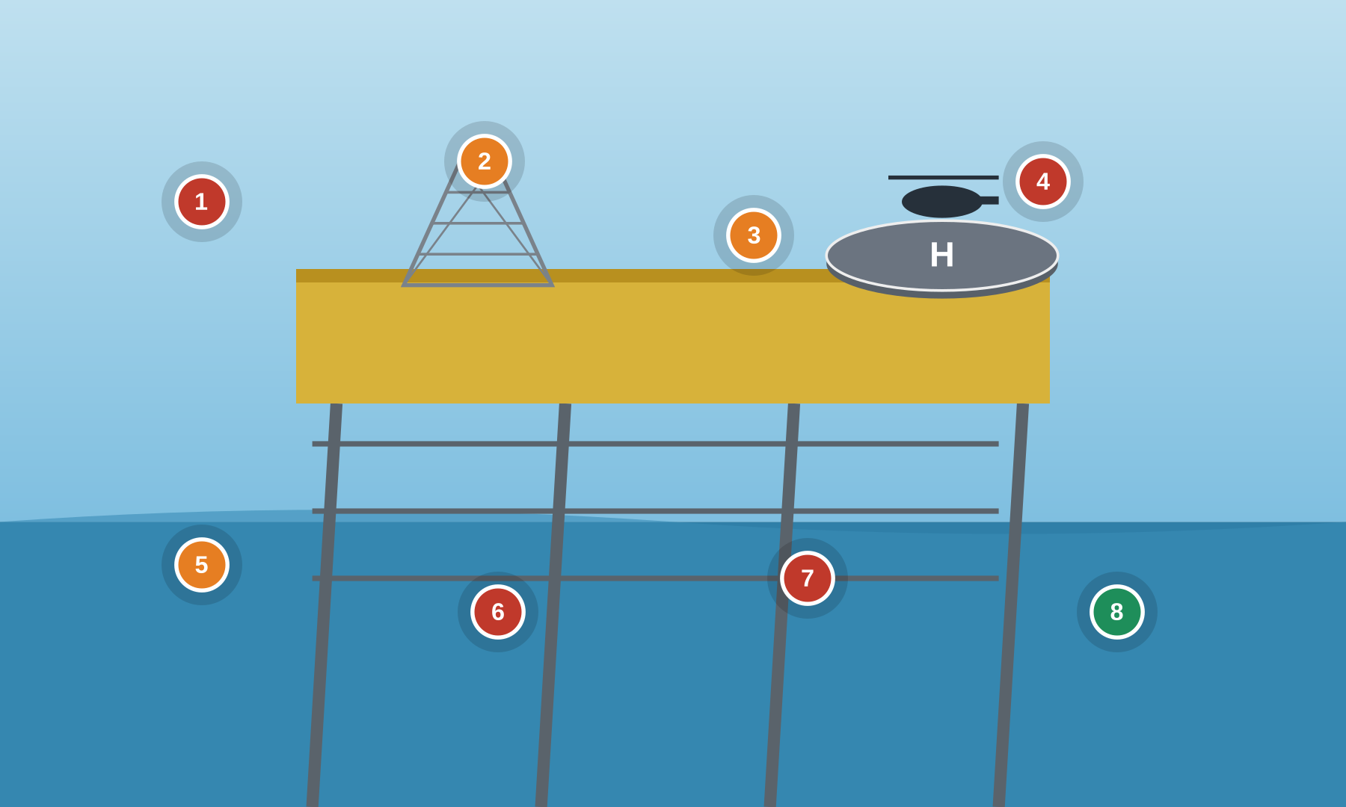
Numbered markers = planted findings. ● cyber ● safety ● good practice
Setting. An offshore production platform. An Integrated Control & Safety System (ICSS) runs process, Fire & Gas (F&G) and Emergency Shutdown (ESD). A helideck supports crew change and refuelling; a VSAT link connects to shore; wireless IIoT sensors monitor equipment.
Key OT/IoT assets: Integrated Control & Safety System (ICSS) · Fire & Gas (F&G) system · ESD valves & logic · Helideck control & refuelling PLC · VSAT / satellite link · Wireless IIoT sensors
People & roles: Offshore Installation Manager (OIM) · Control-room operator · Instrument/automation tech · Turnaround contractor · Helicopter crew / HLO
Processes: Production control (ICSS) · Fire & Gas detection · Emergency shutdown · Helideck ops & refuelling · Crew change / turnaround
What to look for
# | What to look for | Standards flagged — requirement ID & name
1 | VSAT flat to shore Cyber  Satellite/VSAT link to shore routes flat with no firewall or zone boundary. | 3-3 SR 5.2 Zone boundary protection  3-3 SR 1.13 Access via untrusted networks  4-2 NDR 5.2 Zone boundary protection
2 | F&G inhibited Safety  Fire & Gas detector outputs inhibited/forced at the HMI — detection defeated. | PLC #7 Validate and alert for paired inputs / outputs  PLC #20 Trap false negatives and false positives for critical alerts  84.09 Operation Bypass / override management for the SIS
3 | Helideck PLC on process net Safety  Helideck status/refuelling PLC shares the process control network; no partitioning. | 3-3 SR 5.1 Network segmentation  3-3 SR 5.4 Application partitioning  PLC #13 Disable unused / unneeded communication ports and protocols
4 | Crew-change laptop/USB Cyber  Turnaround contractor brings an unmanaged laptop and USB onto the ICSS during crew change. | 3-3 SR 2.3 Use control for portable and mobile devices  3-3 SR 3.2 Malicious code protection  4-2 CR 2.13 Use of physical diagnostic and test interfaces
5 | ESD override no confirm Safety  ESD valve in maintenance override with no independent confirmation or MOC. | 84.09 Operation Management of change (MOC) for SIS security  PLC #2 Track operating modes  3-3 SR 2.1 Authorization enforcement
6 | Shared OIM account Cyber  Shared 'OIM/operator' account on the ICSS; no per-user accounts. | 3-3 SR 1.1 Human user identification and authentication  3-3 SR 1.3 Account management  3-3 SR 1.5 Authenticator management
7 | Open wireless IIoT Cyber  Wireless gas/vibration IIoT sensors run with no encryption or device authentication. | 3-3 SR 1.6 Wireless access management  3-3 SR 2.2 Wireless use control  3-3 SR 4.3 Use of cryptography
8 | Defined safe state + recovery Good practice  GOOD PRACTICE: ICSS has a defined safe state on power loss and a tested recovery procedure. | PLC #15 Define a safe process state in case of a PLC restart  3-3 SR 7.4 Control system recovery and reconstitution  3-3 SR 7.5 Emergency power
Photoreal image-generation prompt
Feed this to your image tool to render a photoreal “spot-the-issue” base scene matching the corporate example.
Photorealistic wide shot of an offshore oil platform at sea, topside process modules, a helideck with a helicopter landing, ocean and sky behind. Training tells: a control-room screen shows 'F&G detectors – INHIBITED', an ESD valve has a 'MAINTENANCE OVERRIDE' tag, a VSAT dome with a network note 'no firewall to shore', a contractor carrying an open laptop and USB drive across the deck during crew change, a sticky note 'ICSS: OIM / offshore1', small wireless sensor pucks on pipework labelled 'open Wi-Fi'. Bright maritime daylight, realistic offshore detail, sense of scale, no text overlays or annotations.
ELECTRIC Electric — Transmission Substation
HV substation — RTU, protective relays (IEC 61850), GOOSE, control house
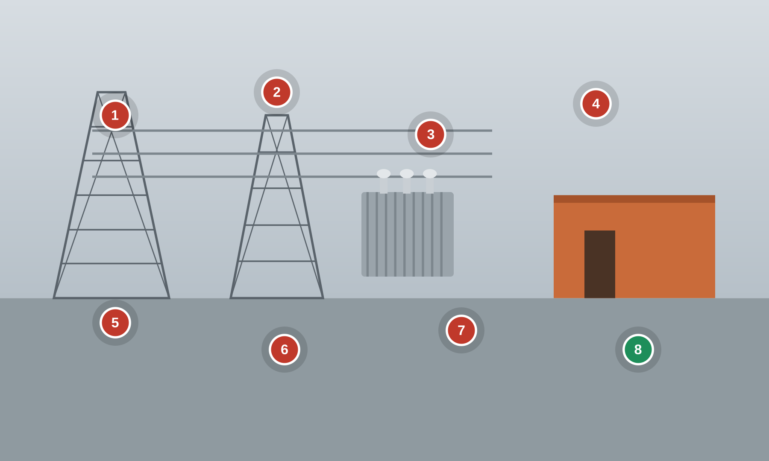
Numbered markers = planted findings. ● cyber ● safety ● good practice
Setting. A high-voltage transmission substation. Protective relays (IEDs) trip breakers over an IEC 61850 station bus (GOOSE/SV); a substation RTU/gateway telemeters to the SCADA/EMS; a control house holds relay panels and the station HMI.
Key OT/IoT assets: Protective relays / IEDs · Substation RTU / gateway · IEC 61850 station bus (GOOSE/SV) · Station HMI · Power transformers & breakers · Managed station switches
People & roles: System operator (control center) · Protection & control engineer · Substation technician · Relay test contractor · Physical security / access
Processes: Protection & tripping · Remote SCADA/EMS telemetry · Relay setting changes · Firmware maintenance · Physical access control
What to look for
# | What to look for | Standards flagged — requirement ID & name
1 | Unauthenticated IEC 61850 Cyber  Relay engineering access over unencrypted IEC 61850 with no device authentication. | 3-3 SR 1.2 Software process and device identification and authentication  3-3 SR 3.1 Communication integrity  4-2 CR 1.2 Software process and device identification and authentication
2 | Dial-in default password Cyber  Substation RTU cellular/dial-up on a default password with no MFA. | 3-3 SR 1.13 Access via untrusted networks  3-3 SR 1.5 Authenticator management  3-3 SR 1.7 Strength of password-based authentication
3 | Laptop bridges IT/OT Cyber  Station HMI on an engineering laptop bridged to the corporate network. | 3-3 SR 5.1 Network segmentation  3-3 SR 5.2 Zone boundary protection  4-2 CR 5.1 Network segmentation
4 | Relay change, no approval/audit Cyber  Protective-relay settings can be changed with no dual-approval and no audit record. | 3-3 SR 2.1 Authorization enforcement  3-3 SR 2.8 Auditable events  3-3 SR 2.12 Non-repudiation
5 | Control house unsecured Cyber  Control-house door propped open, relay panels unlocked — physical access uncontrolled. | 4-2 EDR 3.11 Physical tamper resistance and detection  4-2 CR 2.13 Use of physical diagnostic and test interfaces  3-3 SR 2.1 Authorization enforcement
6 | GOOSE not monitored Cyber  GOOSE/Sampled-Value traffic is not monitored for anomalies or spoofing. | 3-3 SR 6.2 Continuous monitoring  3-3 SR 3.1 Communication integrity  3-3 SR 5.1 Network segmentation
7 | Unpatched IED firmware Cyber  IED firmware unpatched with no signed-update mechanism. | 4-2 EDR 3.10 Support for updates  4-2 EDR 3.14 Integrity of the boot process  3-3 SR 7.8 Control system component inventory
8 | Segmented bus + SIEM Good practice  GOOD PRACTICE: segmented station bus with switch ACLs and syslog to a SIEM. | 4-2 NDR 5.2 Zone boundary protection  3-3 SR 6.1 Audit log accessibility  3-3 SR 5.1 Network segmentation
Photoreal image-generation prompt
Feed this to your image tool to render a photoreal “spot-the-issue” base scene matching the corporate example.
Photorealistic wide shot of a high-voltage electrical substation, transmission towers, large power transformers and bus work, a small brick control house. Training tells: the control-house door is propped open with no badge reader in use, inside a rack of protective relays with a panel open and a laptop wired to a relay, a screen shows 'relay settings – change (no approval)', a cellular modem with a note 'dial-in: admin/admin', a managed switch with a mirror of IT and OT cables, a sticky note 'GOOSE not monitored'. Overcast daylight, realistic utility detail, no text overlays or annotations.
ELECTRIC Electric — Smart Meters & Distribution Automation
AMI on homes & buildings — smart meters, RF mesh, head-end, reclosers, HAN
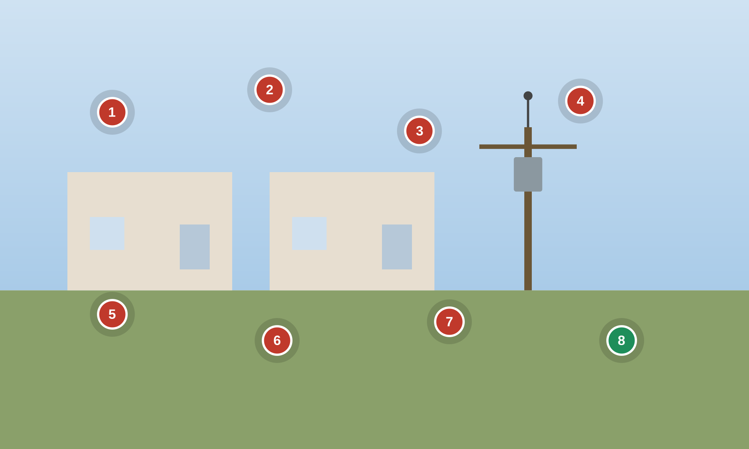
Numbered markers = planted findings. ● cyber ● safety ● good practice
Setting. Smart meters on homes and buildings report over an RF mesh to collectors and an AMI head-end; distribution automation (reclosers, capacitor banks) is controlled in the field; home-area-network (HAN) gateways connect to meters.
Key OT/IoT assets: Residential/commercial smart meters · RF mesh + data collectors · AMI head-end system · Distribution automation (reclosers) · Home-area network (HAN) gateway · Meter disconnect switch
People & roles: Distribution operator · AMI / metering engineer · Field service technician · Utility customer · Meter data management (MDM) team
Processes: Meter reading & billing · Remote connect / disconnect · Firmware management (fleet) · Distribution automation control · Tamper / outage detection
What to look for
# | What to look for | Standards flagged — requirement ID & name
1 | Broken meter seal / local port Cyber  Meter seal broken; local optical/serial port allows on-site reprogramming. | 4-2 EDR 3.11 Physical tamper resistance and detection  4-2 CR 2.13 Use of physical diagnostic and test interfaces  3-3 SR 3.4 Software and information integrity
2 | Default RF-mesh keys Cyber  AMI RF mesh uses weak/default keys; traffic can be joined or read. | 3-3 SR 1.6 Wireless access management  3-3 SR 4.3 Use of cryptography  4-2 NDR 1.6 Wireless access management
3 | Unsigned firmware push Cyber  Head-end pushes meter firmware fleet-wide with no signature verification (mass-update risk). | 3-3 SR 3.4 Software and information integrity  4-2 EDR 3.14 Integrity of the boot process  4-2 EDR 3.10 Support for updates
4 | Disconnect not authz-controlled Cyber  Remote connect/disconnect command not authorization-controlled (mass-disconnect abuse). | 3-3 SR 2.1 Authorization enforcement  3-3 SR 1.2 Software process and device identification and authentication  3-3 SR 3.5 Input validation
5 | Plaintext DNP3 recloser Cyber  Distribution recloser on cellular with plaintext DNP3 and no secure authentication. | 3-3 SR 3.1 Communication integrity  3-3 SR 4.3 Use of cryptography  PLC #13 Disable unused / unneeded communication ports and protocols
6 | HAN bridged to meter Cyber  Home IoT / HAN gateway bridged to the meter with no segmentation. | 3-3 SR 5.1 Network segmentation  3-3 SR 5.3 General purpose person-to-person communication restrictions  3-3 SR 4.1 Information confidentiality
7 | No fleet inventory Cyber  No accurate inventory of the meter fleet; stale/unknown firmware versions in the field. | 3-3 SR 7.8 Control system component inventory  3-3 SR 6.2 Continuous monitoring  4-2 EDR 3.10 Support for updates
8 | Signed FW + per-device keys Good practice  GOOD PRACTICE: meters use signed firmware, unique per-device keys and tamper alarms to the head-end. | 4-2 EDR 3.12 Provisioning product supplier roots of trust  4-2 EDR 3.13 Provisioning asset owner roots of trust  3-3 SR 1.2 Software process and device identification and authentication
Photoreal image-generation prompt
Feed this to your image tool to render a photoreal “spot-the-issue” base scene matching the corporate example.
Photorealistic shot of a suburban street and a building exterior with electricity smart meters on the wall, an RF mesh antenna on a utility pole, a pole-mounted recloser. Training tells: a smart meter cover seal is broken and an optical probe is clipped to its port, a technician tablet shows 'firmware push – no signature check', a note on the collector reads 'mesh key: default', a recloser cabinet with a cellular router labelled 'DNP3 plaintext', a home IoT gateway wired to the meter. Daytime residential lighting, realistic utility detail, no text overlays or annotations.
NATURAL GAS Natural Gas — Farm Tap, Pipeline Station & Compression
Gas gathering — farm-tap RTU, metering, compressor ESD, odorizer, telemetry
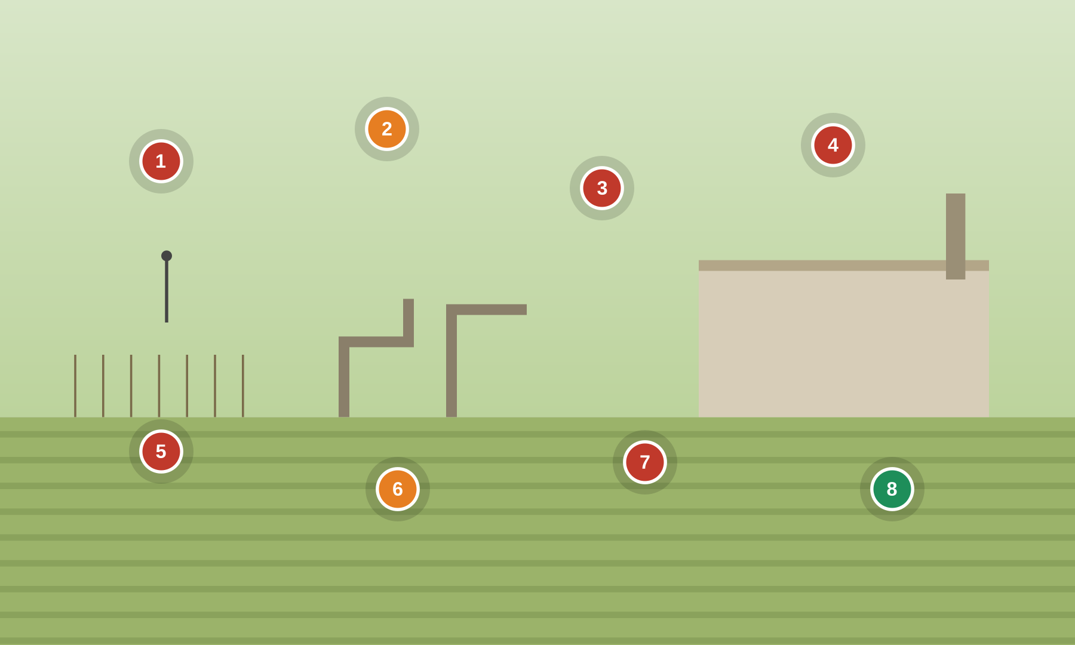
Numbered markers = planted findings. ● cyber ● safety ● good practice
Setting. A natural-gas gathering system runs through farmland: a farm-tap RTU and roadside pipeline metering station telemeter over radio/cellular; a compressor station moves gas with ESD and high-pressure trips; an odorizer injects mercaptan for public safety.
Key OT/IoT assets: Farm-tap RTU / cabinet · Pipeline metering PLC · Compressor station PLC + VFD · ESD & high-pressure trip · Odorizer / injection system · SCADA telemetry radio
People & roles: Gas controller (control center) · Measurement / metering tech · Compressor-station operator · Landowner / farmer (adjacent) · Vendor remote support
Processes: Gas gathering & telemetry · Custody metering · Compression & pressure control · Odorization (public safety) · Remote vendor support
What to look for
# | What to look for | Standards flagged — requirement ID & name
1 | Open farm-tap RTU + radio Cyber  Roadside farm-tap RTU cabinet unlocked; telemetry radio unencrypted. | 4-2 EDR 3.11 Physical tamper resistance and detection  3-3 SR 1.6 Wireless access management  3-3 SR 4.3 Use of cryptography
2 | Compressor ESD bypassed Safety  Compressor ESD and high-pressure trip bypassed for operations. | 84.09 Operation Bypass / override management for the SIS  PLC #15 Define a safe process state in case of a PLC restart  PLC #2 Track operating modes
3 | Writable metering PLC Cyber  Metering PLC on writable Modbus; custody values can be spoofed (fraud). | 3-3 SR 3.1 Communication integrity  3-3 SR 3.5 Input validation  PLC #8 Validate HMI input variables at the PLC level, not only at the HMI
4 | Flat station network Cyber  Station SCADA is flat to the enterprise network with no DMZ. | 3-3 SR 5.1 Network segmentation  3-3 SR 5.2 Zone boundary protection  4-2 CR 5.1 Network segmentation
5 | Always-on vendor cellular Cyber  Vendor cellular remote access to the compressor VFD is always on and on default credentials. | 3-3 SR 1.13 Access via untrusted networks  3-3 SR 1.5 Authenticator management  3-3 SR 2.6 Remote session termination
6 | Odorizer alarm inhibited Safety  Odorant-injection low alarm inhibited — public-safety odorization not assured. | PLC #20 Trap false negatives and false positives for critical alerts  PLC #12 Validate inputs based on physical plausibility  3-3 SR 6.2 Continuous monitoring
7 | Unauthenticated polling Cyber  Shared SCADA polling over radio with no device authentication (spoofable). | 3-3 SR 1.2 Software process and device identification and authentication  3-3 SR 3.1 Communication integrity  4-2 CR 1.2 Software process and device identification and authentication
8 | Hardened field RTUs Good practice  GOOD PRACTICE: field RTUs have unused ports disabled and a signed configuration baseline. | PLC #13 Disable unused / unneeded communication ports and protocols  3-3 SR 7.6 Network and security configuration settings  3-3 SR 7.7 Least functionality
Photoreal image-generation prompt
Feed this to your image tool to render a photoreal “spot-the-issue” base scene matching the corporate example.
Photorealistic wide shot of a natural-gas pipeline metering and compressor station beside farmland, a small roadside RTU cabinet near a fence line, pipe risers and a compressor building. Training tells: the roadside RTU cabinet is unlocked and open with a radio antenna, a compressor HMI shows 'High-pressure trip – BYPASS', a metering laptop wired into an open cabinet, a note 'cell remote: default pw', an odorizer panel reads 'inject alarm INHIBITED', a network switch mixing field and office cables. Rural daylight, crops in the background, realistic detail, no text overlays or annotations.
NATURAL GAS Natural Gas — LNG Terminal
LNG liquefaction/regas — jetty loading arms, ship-shore link, SIS, F&G
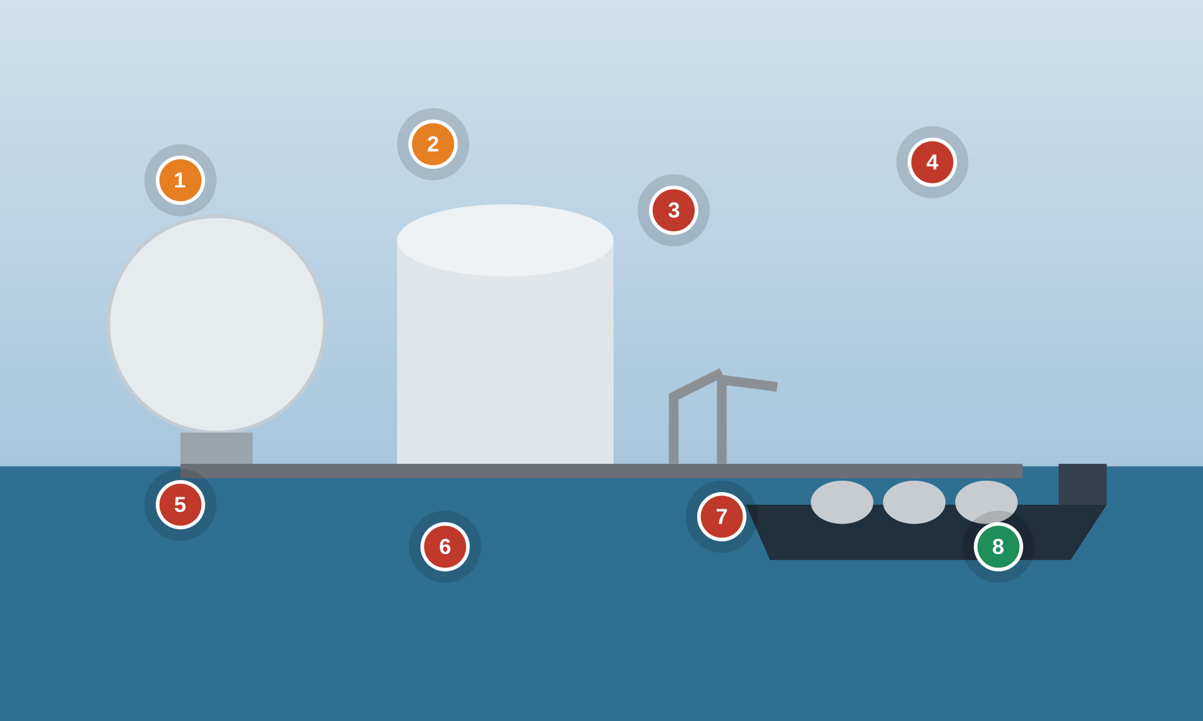
Numbered markers = planted findings. ● cyber ● safety ● good practice
Setting. An LNG terminal liquefies or regasifies gas and loads/unloads LNG carriers at a jetty. A DCS runs process; an independent SIS and Fire & Gas protect against release; loading arms and a ship-shore link (SSL) manage transfer; mooring/berth monitoring uses IIoT.
Key OT/IoT assets: LNG process DCS · Independent SIS + HIPPS · Fire & Gas (F&G) system · Jetty loading arms + ESD · Ship-shore link (SSL) · Berth / mooring IIoT monitoring
People & roles: Terminal control operator · Jetty / marine loading master · Functional safety engineer · LNG carrier crew · DCS/SIS vendor (remote)
Processes: Liquefaction / regasification · Ship loading / unloading (custody) · Emergency shutdown (ESD/ESD-2) · Fire & Gas detection · Mooring & berth monitoring
What to look for
# | What to look for | Standards flagged — requirement ID & name
1 | Jetty ESD not independent Safety  Jetty loading-arm ESD and ship-shore link are not on an independent SIS zone. | 84.09 Realization SIS zones and conduits (SIS as a separate zone)  3-3 SR 5.4 Application partitioning  3-3 SR 5.1 Network segmentation
2 | F&G forced from commissioning Safety  Fire & Gas and high-level tank trips forced during commissioning and never restored. | 84.09 Operation Management of change (MOC) for SIS security  PLC #7 Validate and alert for paired inputs / outputs  PLC #15 Define a safe process state in case of a PLC restart
3 | Unauthenticated ship-shore link Cyber  Ship-shore custody/telemetry link over unauthenticated serial/OPC. | 3-3 SR 3.1 Communication integrity  3-3 SR 1.2 Software process and device identification and authentication  3-3 SR 4.3 Use of cryptography
4 | DCS laptop shared w/ email Cyber  DCS/SIS engineering laptop also used for corporate email and internet. | 3-3 SR 2.3 Use control for portable and mobile devices  3-3 SR 5.1 Network segmentation  3-3 SR 3.2 Malicious code protection
5 | Open mooring IIoT Cyber  Berth control and mooring-monitoring IIoT run wireless with no encryption. | 3-3 SR 1.6 Wireless access management  3-3 SR 4.3 Use of cryptography  4-2 NDR 1.6 Wireless access management
6 | Always-on refrigeration VPN Cyber  Vendor VPN into compressor/refrigeration controls is permanently connected. | 3-3 SR 1.13 Access via untrusted networks  3-3 SR 2.6 Remote session termination  3-3 SR 6.2 Continuous monitoring
7 | Shared console, no lock Cyber  Operator consoles on shared credentials with no session lock. | 3-3 SR 1.1 Human user identification and authentication  3-3 SR 2.5 Session lock  3-3 SR 1.5 Authenticator management
8 | Independent HIPPS/SIS, MOC Good practice  GOOD PRACTICE: independent HIPPS/SIS in a locked zone with MOC enforced on all changes. | 84.09 Operation Management of change (MOC) for SIS security  3-3 SR 7.6 Network and security configuration settings  4-2 EDR 3.11 Physical tamper resistance and detection
Photoreal image-generation prompt
Feed this to your image tool to render a photoreal “spot-the-issue” base scene matching the corporate example.
Photorealistic wide shot of an LNG terminal at a waterfront, large spherical and full-containment LNG storage tanks, a jetty with articulated loading arms and an LNG carrier moored alongside. Training tells: a control screen shows 'F&G / high-level trip – FORCED (commissioning)', a jetty ESD panel wired to a shared network switch, a shared operator console with 'no session lock', a ship-shore link box labelled 'serial – no auth', small wireless mooring sensors labelled 'open', a laptop with corporate email open plugged into the DCS. Coastal daylight, realistic industrial detail, sense of scale, no text overlays or annotations.
MARITIME Maritime — Vessel Bridge & Engine Room
Ship OT — ECDIS, IBS, GNSS, engine/propulsion PLC (PMS), VSAT

Numbered markers = planted findings. ● cyber ● safety ● good practice
Setting. A vessel's bridge runs an Integrated Bridge System (IBS) with ECDIS and radar fed by GNSS/GPS; the engine room runs an Integrated Automation System (IAS) / Power Management System and propulsion PLCs; VSAT and crew Wi-Fi connect the ship.
Key OT/IoT assets: ECDIS + radar (IBS) · GNSS / GPS receiver · Engine / propulsion PLC (PMS) · Integrated Automation System (IAS) · VSAT + crew Wi-Fi · Serial-to-IP OT gateways
People & roles: Master / OOW (officer of the watch) · Chief engineer · Electro-technical officer (ETO) · Crew (personal devices) · OEM remote support
Processes: Navigation (ECDIS/IBS) · Propulsion & power management · Chart & software updates · Ballast / steering control · OEM remote support
What to look for
# | What to look for | Standards flagged — requirement ID & name
1 | ECDIS USB updates Cyber  ECDIS chart/software updates loaded via crew USB with no scanning. | 3-3 SR 2.3 Use control for portable and mobile devices  3-3 SR 3.2 Malicious code protection  4-2 CR 2.13 Use of physical diagnostic and test interfaces
2 | No GNSS spoof detection Safety  GNSS/GPS feeding ECDIS/DP has no jamming or spoofing detection (navigation integrity). | 3-3 SR 3.5 Input validation  PLC #12 Validate inputs based on physical plausibility  3-3 SR 6.2 Continuous monitoring
3 | Crew Wi-Fi bridged to nav Cyber  VSAT/crew Wi-Fi bridged flat to the navigation/IAS network. | 3-3 SR 5.1 Network segmentation  3-3 SR 5.2 Zone boundary protection  4-2 NDR 5.2 Zone boundary protection
4 | Always-on OEM satellite access Cyber  Engine/propulsion PLC (PMS) has always-on OEM remote access over satellite. | 3-3 SR 1.13 Access via untrusted networks  3-3 SR 2.6 Remote session termination  3-3 SR 6.2 Continuous monitoring
5 | Shared bridge login Cyber  Shared bridge/engine control login; no per-user accounts. | 3-3 SR 1.1 Human user identification and authentication  3-3 SR 1.3 Account management  3-3 SR 1.5 Authenticator management
6 | Steering safe-state undefined Safety  Ballast/steering alarms overridden; no defined safe state on a PLC restart. | PLC #15 Define a safe process state in case of a PLC restart  PLC #2 Track operating modes  PLC #20 Trap false negatives and false positives for critical alerts
7 | Default gateway creds Cyber  Serial-to-IP OT gateways on default credentials with open ports. | 3-3 SR 1.5 Authenticator management  3-3 SR 1.7 Strength of password-based authentication  PLC #13 Disable unused / unneeded communication ports and protocols
8 | Segmented per IACS E26/E27 Good practice  GOOD PRACTICE: segmented networks, signed navigation updates and an asset inventory (aligns to IACS UR E26/E27). | 3-3 SR 5.1 Network segmentation  3-3 SR 7.8 Control system component inventory  4-2 EDR 3.14 Integrity of the boot process
Photoreal image-generation prompt
Feed this to your image tool to render a photoreal “spot-the-issue” base scene matching the corporate example.
Photorealistic shot from a ship's bridge, ECDIS and radar screens, windows over the bow at sea, and an inset of the engine control room with automation panels. Training tells: an ECDIS screen with a crew USB stick plugged in labelled 'chart update', a note 'no GPS spoof check', a crew Wi-Fi router cabled to the navigation network switch, an engine PMS screen showing 'OEM remote – always on (satellite)', a sticky note 'bridge login: master / ship123', a serial-to-IP gateway labelled 'default pw'. Marine daylight through the windows, realistic detail, no text overlays or annotations.
MARITIME Maritime — Port & Container Terminal
Container terminal — STS/RTG cranes, TOS, reefers, gate OCR, radio remote control
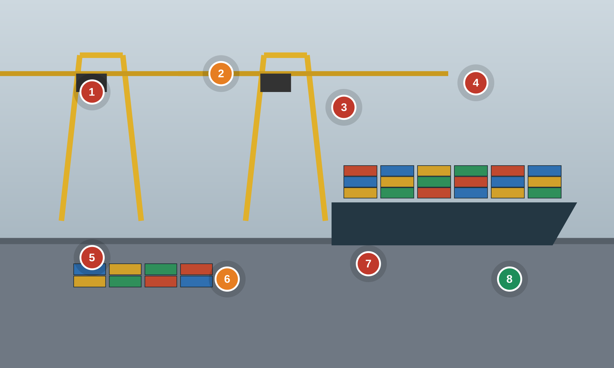
Numbered markers = planted findings. ● cyber ● safety ● good practice
Setting. A container terminal moves boxes with ship-to-shore (STS) and yard (RTG/RMG) cranes driven by PLCs; a Terminal Operating System (TOS) coordinates moves; reefer racks, gate OCR and radio remote-control of cranes add IoT/OT exposure.
Key OT/IoT assets: STS ship-to-shore crane PLC/drives · RTG/RMG yard crane PLC · Terminal Operating System (TOS) · Reefer monitoring / gate OCR (IoT) · Crane radio remote control · Anti-collision / load-moment interlocks
People & roles: Terminal operations controller · Crane operator / driver · Crane maintenance technician · OEM crane support (remote) · Gate / yard staff
Processes: Container handling (crane control) · Terminal operations (TOS) · Crane maintenance & programming · Reefer / gate monitoring · Radio remote crane control
What to look for
# | What to look for | Standards flagged — requirement ID & name
1 | Crane drive default creds/Wi-Fi Cyber  STS crane PLC/drive on shared Wi-Fi with default credentials and OEM remote diagnostics. | 3-3 SR 1.6 Wireless access management  3-3 SR 1.13 Access via untrusted networks  3-3 SR 1.5 Authenticator management
2 | Anti-collision bypassed Safety  Crane anti-collision / load-moment safety interlock bypassed. | 84.09 Operation Bypass / override management for the SIS  PLC #7 Validate and alert for paired inputs / outputs  PLC #15 Define a safe process state in case of a PLC restart
3 | TOS flat to crane OT Cyber  Terminal Operating System (IT) bridged flat to the crane OT network. | 3-3 SR 5.1 Network segmentation  3-3 SR 5.2 Zone boundary protection  4-2 CR 5.1 Network segmentation
4 | Internet-exposed gate/reefer IoT Cyber  Gate OCR and reefer-monitoring IoT devices on default credentials and internet-exposed. | 3-3 SR 1.5 Authenticator management  3-3 SR 5.2 Zone boundary protection  3-3 SR 1.13 Access via untrusted networks
5 | USB crane programming Cyber  Contractor uses an unmanaged USB to transfer crane PLC programs. | 3-3 SR 2.3 Use control for portable and mobile devices  3-3 SR 3.4 Software and information integrity  4-2 CR 2.13 Use of physical diagnostic and test interfaces
6 | Unauthenticated radio control Safety  Radio remote-control of RTG cranes is unauthenticated (spoofable command). | 3-3 SR 1.6 Wireless access management  3-3 SR 2.2 Wireless use control  3-3 SR 4.3 Use of cryptography
7 | No PLC change logging Cyber  No monitoring or logging of PLC program changes on the cranes. | 3-3 SR 2.8 Auditable events  3-3 SR 6.2 Continuous monitoring  3-3 SR 2.12 Non-repudiation
8 | Segmented crane zone + baselines Good practice  GOOD PRACTICE: segmented crane OT zone, switch ACLs, signed PLC baselines and a change log. | 4-2 NDR 5.2 Zone boundary protection  3-3 SR 2.8 Auditable events  PLC #5 Use cryptographic and/or checksum integrity checks for PLC code
Photoreal image-generation prompt
Feed this to your image tool to render a photoreal “spot-the-issue” base scene matching the corporate example.
Photorealistic wide shot of a container port terminal, towering ship-to-shore cranes over a container ship, stacks of colorful containers and rubber-tyred gantry cranes in the yard. Training tells: a crane machine-house PLC cabinet open with a laptop and USB drive, a Wi-Fi antenna with a note 'crane drive: admin/admin', a screen showing 'anti-collision interlock – BYPASS', a gate OCR/reefer IoT box labelled 'internet-exposed', a handheld radio remote for a yard crane, a network rack mixing TOS/IT and crane OT cables. Industrial daylight, realistic port detail, sense of scale, no text overlays or annotations.
BUILDINGS & FACILITIES Data Center — Cooling & Mechanical Plant
Critical cooling — chillers, CRAH/CRAC, modular cooling, BMS/BACnet, cold-aisle containment
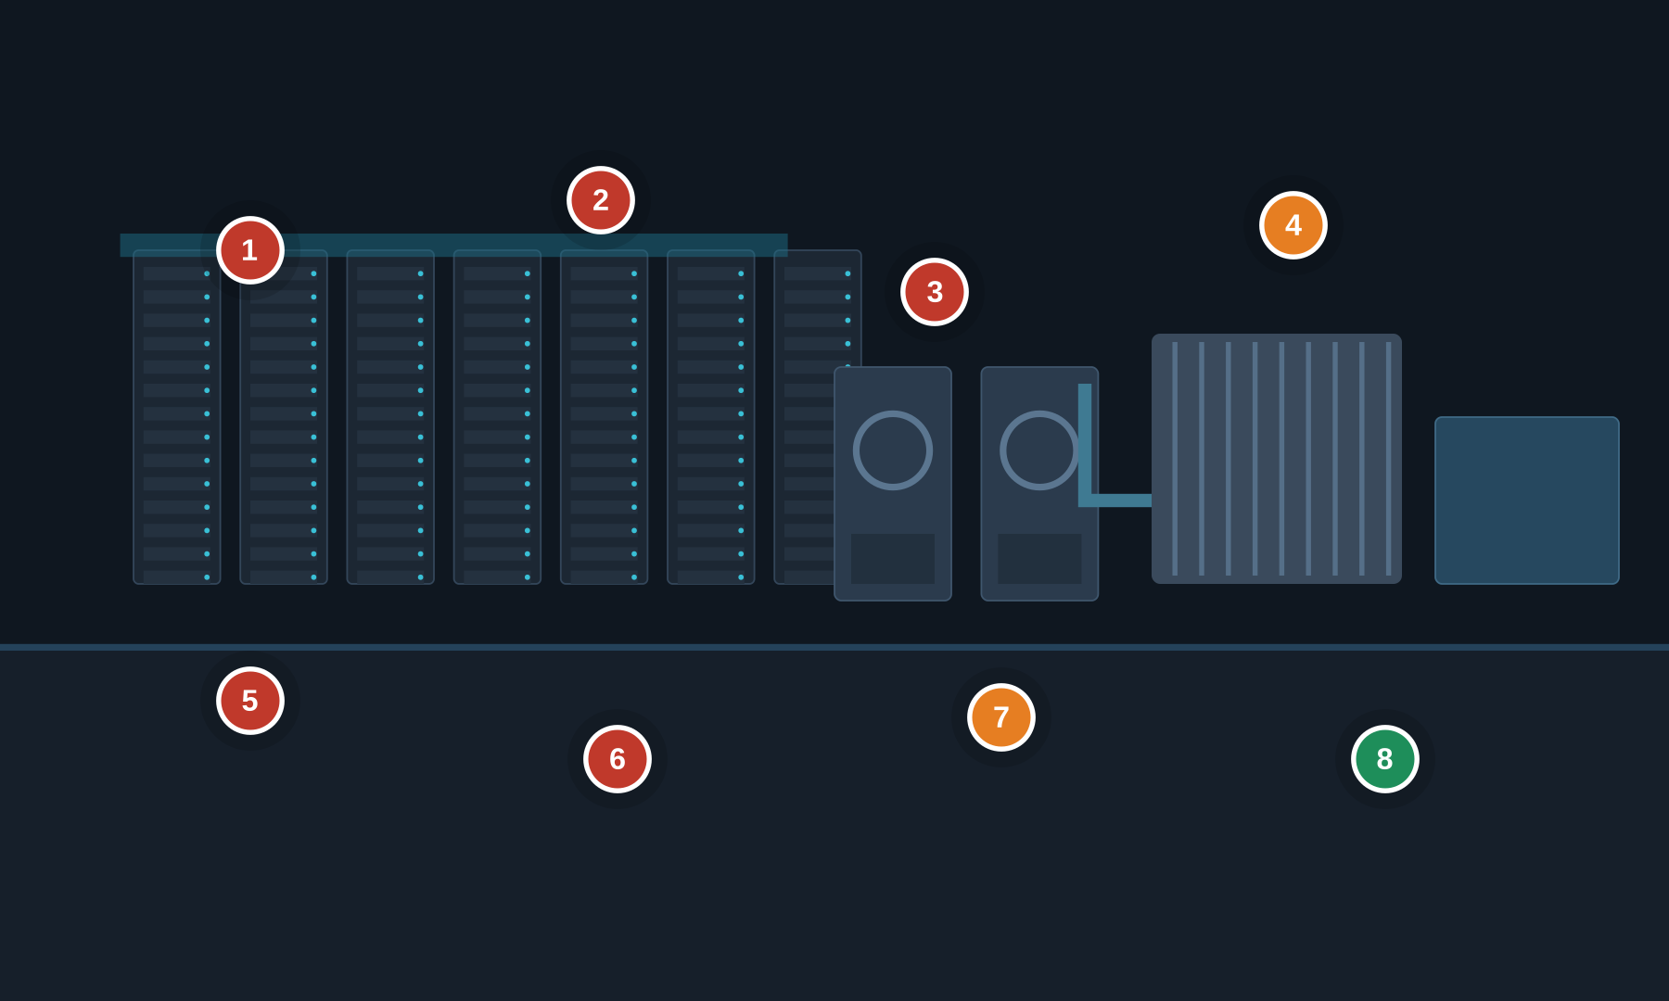
Numbered markers = planted findings. ● cyber ● safety ● good practice
Setting. A data center mechanical plant keeps the white space within temperature. Water-cooled chillers, cooling towers and pumps feed CRAH/CRAC units and containerized/modular cooling; a Building Management System (BMS/BAS) on BACnet/Modbus drives setpoints and sequencing. Loss of cooling is both an availability and an equipment-safety event.
Key OT/IoT assets: Water-cooled chiller plant · CRAH / CRAC units · Modular / containerized cooling units · Cooling tower & condenser pumps · BMS/BAS DDC controllers (BACnet/Modbus) · BMS server / operator workstation
People & roles: Critical-environment / facilities operator · BMS / controls engineer · Mechanical technician · Chiller OEM (remote support) · Data center manager
Processes: Cooling control & setpoints · Chiller sequencing & staging · BMS alarming & trending · Vendor remote maintenance · Change control (MOC)
What to look for
# | What to look for | Standards flagged — requirement ID & name
1 | Flat BMS/BACnet network Cyber  BMS/BACnet shares a flat network reachable from IT/corporate; no segmentation to the cooling controls. | 3-3 SR 5.1 Network segmentation  3-3 SR 5.2 Zone boundary protection  4-2 CR 5.1 Network segmentation
2 | Unauthenticated BACnet writes Cyber  BACnet/Modbus setpoints and commands can be written by anyone on the network; no device authentication. | 3-3 SR 3.1 Communication integrity  3-3 SR 1.2 Software process and device identification and authentication  3-3 SR 3.5 Input validation
3 | Always-on chiller OEM access Cyber  Chiller OEM remote access left permanently connected on default credentials. | 3-3 SR 1.13 Access via untrusted networks  3-3 SR 1.5 Authenticator management  3-3 SR 2.6 Remote session termination
4 | Chiller trip bypassed Safety  Chiller high-pressure / high-temperature trip bypassed at the BMS to keep cooling running. | 84.09 Operation Bypass / override management for the safety function  PLC #2 Track operating modes  PLC #12 Validate inputs based on physical plausibility
5 | Shared BMS login Cyber  Shared 'bms/operator' login on the BMS workstation; no per-user accounts. | 3-3 SR 1.1 Human user identification and authentication  3-3 SR 1.3 Account management  3-3 SR 1.5 Authenticator management
6 | Default modular-cooling creds Cyber  Modular/containerized cooling unit on default web admin credentials with an exposed HTTP interface. | 3-3 SR 1.5 Authenticator management  3-3 SR 1.7 Strength of password-based authentication  3-3 SR 7.7 Least functionality
7 | Failover logic not validated Safety  Cooling redundancy/failover logic unvalidated; one setpoint change can trip a whole hall. | PLC #7 Validate and alert for paired inputs / outputs  PLC #11 Instrument for plausibility checks  3-3 SR 7.1 Denial of service protection
8 | Segmented, monitored BMS Good practice  GOOD PRACTICE: BMS in a segmented zone with monitored BACnet traffic and signed controller configurations. | 3-3 SR 5.2 Zone boundary protection  3-3 SR 6.2 Continuous monitoring  3-3 SR 7.6 Network and security configuration settings
Photoreal image-generation prompt
Feed this to your image tool to render a photoreal “spot-the-issue” base scene matching the corporate example.
Photorealistic wide shot inside a data center cooling and mechanical plant: rows of server racks with cold-aisle containment, large CRAH air handlers, water-cooled chillers with piping and pumps, and a containerized modular cooling unit. Training tells: a BMS operator screen showing 'Chiller high-pressure trip – BYPASS', a network switch with IT and BMS cables mixed together, a laptop plugged into a DDC controller, a sticky note 'BMS: operator/operator', a modular cooling unit web page 'admin/admin', a monitor labelled 'BACnet – no auth', an 'OEM remote access: always on' note. Cool blue LED lighting, realistic detail, no text overlays or annotations.
BUILDINGS & FACILITIES Buildings — Automation & Boiler Plant
Central plant — BAS/BACnet, AHUs, hot-water/steam boilers, burner management (flame safeguard)
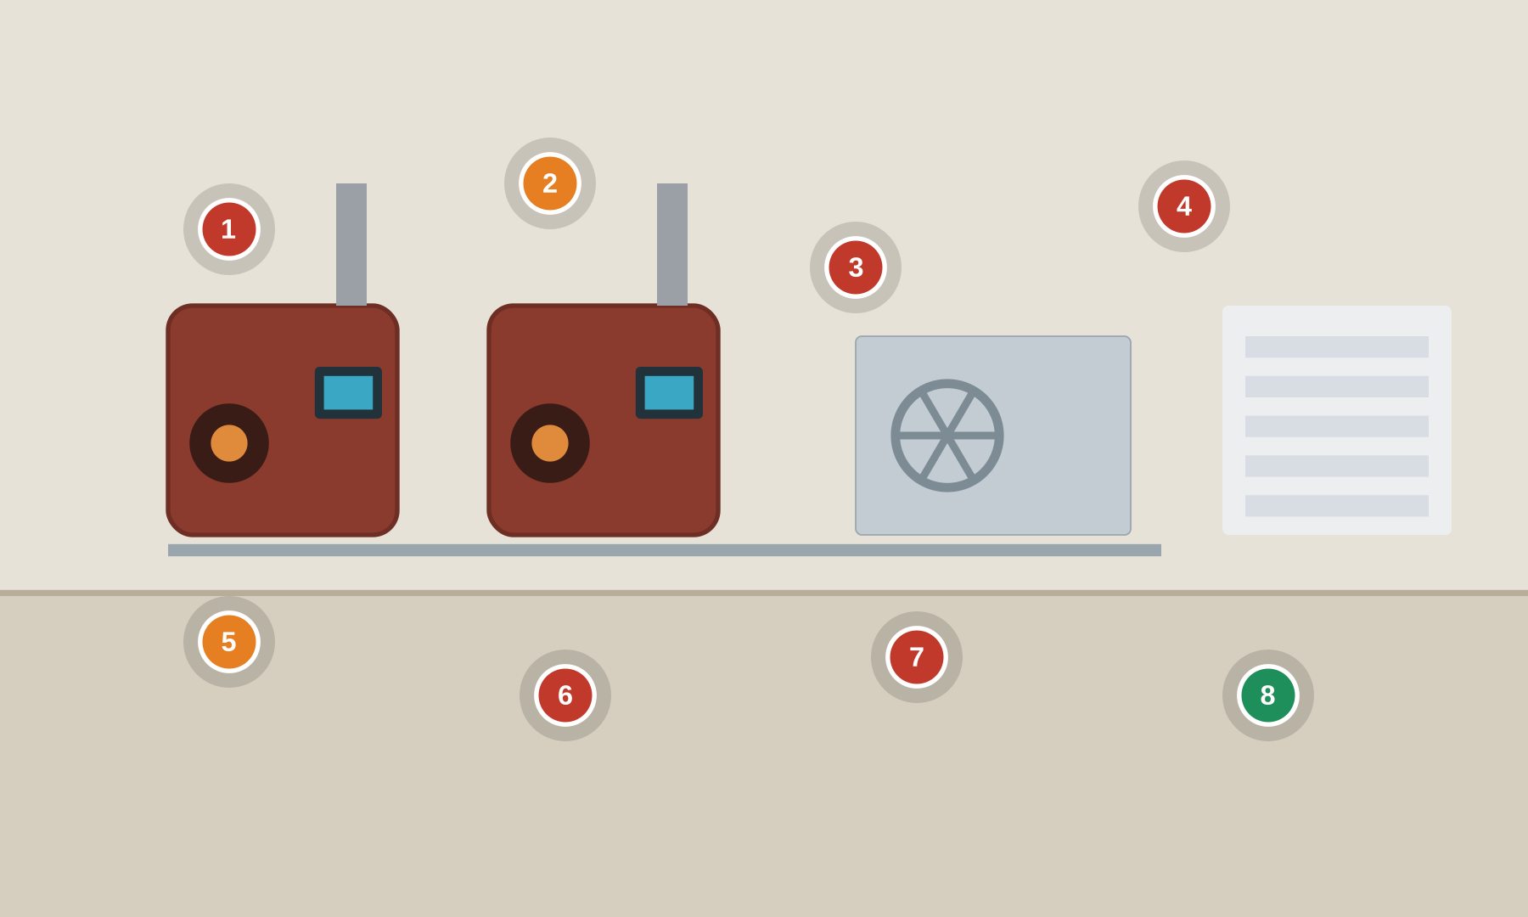
Numbered markers = planted findings. ● cyber ● safety ● good practice
Setting. A commercial building / campus central plant. A Building Automation System (BAS) on BACnet/LonWorks drives air handlers and VAV boxes; hot-water or steam boilers are protected by a burner management system (flame safeguard) and low-water cutoff — a combustion safety function (per NFPA 85 / ASME CSD-1) that a cyber event must not defeat.
Key OT/IoT assets: BAS supervisory controllers + DDC · Air handling units & VAV boxes · Hot-water / steam boilers · Burner management / flame safeguard · Building controls server · BACnet / LonWorks / Modbus field bus
People & roles: Building engineer / operator · Controls / BAS integrator · Boiler technician · OEM burner vendor · Facilities manager
Processes: HVAC scheduling & setpoints · Boiler sequencing & combustion safety · BAS trending & alarms · Integrator remote support · Change control (MOC)
What to look for
# | What to look for | Standards flagged — requirement ID & name
1 | BAS exposed to internet Cyber  BAS supervisory controller reachable from the internet on default credentials. | 3-3 SR 1.13 Access via untrusted networks  3-3 SR 1.5 Authenticator management  3-3 SR 5.2 Zone boundary protection
2 | Burner safeguard forced Safety  Boiler burner-management / flame-safeguard trip bypassed or forced (combustion / explosion hazard). | 84.09 Operation Bypass / override management for the safety function  PLC #15 Define a safe process state in case of a PLC restart  PLC #2 Track operating modes
3 | Integrator laptop across sites Cyber  Integrator laptop moves between customer sites and connects to the BAS with no control or scanning. | 3-3 SR 2.3 Use control for portable and mobile devices  3-3 SR 3.2 Malicious code protection  4-2 CR 2.13 Use of physical diagnostic and test interfaces
4 | Spoofable BACnet commands Cyber  BACnet broadcast with no device authentication; setpoints and commands are spoofable. | 3-3 SR 1.2 Software process and device identification and authentication  3-3 SR 3.1 Communication integrity  3-3 SR 3.5 Input validation
5 | Combustion alarms inhibited Safety  High/low-fire and low-water-cutoff alarms inhibited at the BAS. | PLC #20 Trap false negatives and false positives for critical alerts  PLC #7 Validate and alert for paired inputs / outputs  3-3 SR 6.2 Continuous monitoring
6 | Flat tenant/IT network Cyber  BAS shares a VLAN with tenant/guest and IT networks; no segmentation. | 3-3 SR 5.1 Network segmentation  3-3 SR 5.2 Zone boundary protection  4-2 CR 5.1 Network segmentation
7 | No controller backup/inventory Cyber  No configuration backup of controllers and no inventory of field devices. | 3-3 SR 7.3 Control system backup  3-3 SR 7.8 Control system component inventory  3-3 SR 7.4 Control system recovery and reconstitution
8 | Independent burner management Good practice  GOOD PRACTICE: independent burner management in a locked panel, with MOC and dual-approval on changes. | 84.09 Operation Management of change (MOC) for the safety function  3-3 SR 2.1 Authorization enforcement  4-2 EDR 3.11 Physical tamper resistance and detection
Photoreal image-generation prompt
Feed this to your image tool to render a photoreal “spot-the-issue” base scene matching the corporate example.
Photorealistic shot of a commercial building mechanical / boiler room: two hot-water boilers with flue stacks and burner assemblies, an air handling unit, pumps and piping, and a wall-mounted building automation (BAS) control panel. Training tells: a BAS screen 'Burner management trip – FORCED', a low-water cutoff with a 'BYPASS' tag zip-tied to it, an integrator laptop wired into the open BAS panel, a sticky note 'BAS: admin/admin', a router labelled 'internet-exposed', a BACnet controller with its cover open. Industrial mechanical-room lighting, realistic detail, no text overlays or annotations.
BUILDINGS & FACILITIES Buildings — Fire & Life Safety Systems
FACP, suppression release, smoke control, mass notification — increasingly IP-networked
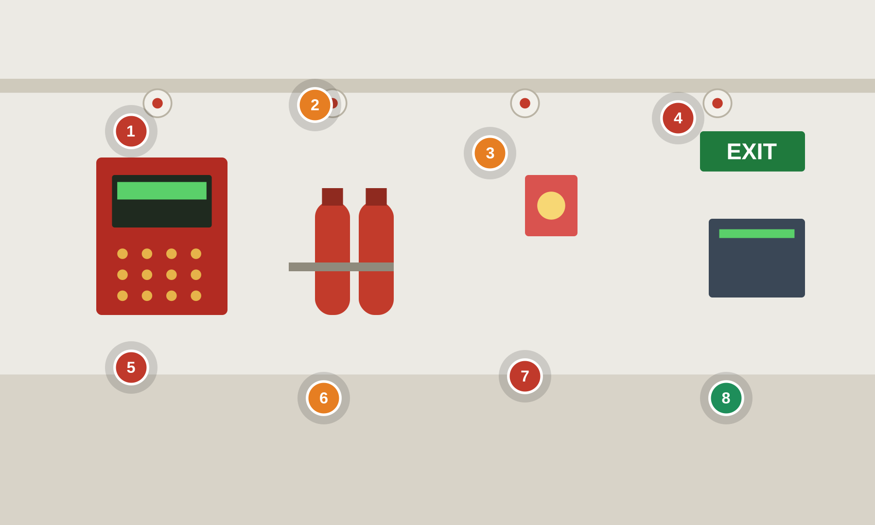
Numbered markers = planted findings. ● cyber ● safety ● good practice
Setting. A building fire & life safety installation. A fire alarm control panel (FACP) with addressable detectors drives alarm and evacuation; suppression release (pre-action / clean-agent) and smoke-control HVAC are safety functions; mass notification / voice evacuation warns occupants. These follow NFPA 72 / life-safety codes — the flags below are the cyber overlay on top of that governance, not a replacement for it.
Key OT/IoT assets: Fire alarm control panel (FACP) · Suppression release panel (pre-action / clean-agent) · Smoke-control (HVAC interface) · Mass notification / voice evacuation · IP fire-alarm gateway · Emergency generator / ATS interface
People & roles: Fire safety director · Life-safety / fire-alarm technician · BAS integrator · Authority Having Jurisdiction (AHJ) · Security operations
Processes: Detection & alarm · Suppression release logic · Smoke-control sequencing · Mass notification · Testing / inspection & MOC
What to look for
# | What to look for | Standards flagged — requirement ID & name
1 | FACP on IT network Cyber  Fire alarm panel networked to BAS/IT with no segmentation or firewall. | 3-3 SR 5.1 Network segmentation  3-3 SR 5.2 Zone boundary protection  4-2 NDR 5.2 Zone boundary protection
2 | Suppression release bypassed Safety  Pre-action / clean-agent suppression release can be disabled from a networked HMI with no control. | 84.09 Operation Bypass / override management for the safety function  PLC #2 Track operating modes  3-3 SR 2.1 Authorization enforcement
3 | Smoke-control spoofable Safety  Smoke-control HVAC sequence integrity not protected; BACnet commands are spoofable. | 3-3 SR 3.1 Communication integrity  3-3 SR 3.5 Input validation  PLC #7 Validate and alert for paired inputs / outputs
4 | Plaintext fire gateway Cyber  IP fire-alarm gateway on default credentials, reporting off-site over plaintext. | 3-3 SR 1.5 Authenticator management  3-3 SR 3.1 Communication integrity  3-3 SR 4.3 Use of cryptography
5 | Mass-notification reachable Cyber  Mass notification / voice evac reachable from IT with no authentication (false alerts or silencing). | 3-3 SR 1.2 Software process and device identification and authentication  3-3 SR 2.1 Authorization enforcement  3-3 SR 5.2 Zone boundary protection
6 | Zones left disabled Safety  Detector/zone disable and walk-test left active, suppressing real alarms. | PLC #20 Trap false negatives and false positives for critical alerts  PLC #2 Track operating modes  3-3 SR 6.2 Continuous monitoring
7 | No change control on panel Cyber  No change control or audit on fire-panel programming changes. | 3-3 SR 2.8 Auditable events  3-3 SR 2.12 Non-repudiation  84.09 Operation Management of change (MOC) for the safety function
8 | Segmented life-safety net Good practice  GOOD PRACTICE: life-safety network segmented and monitored; panel programming under MOC with AHJ sign-off. | 84.09 Operation Management of change (MOC) for the safety function  3-3 SR 5.2 Zone boundary protection  3-3 SR 6.2 Continuous monitoring
Photoreal image-generation prompt
Feed this to your image tool to render a photoreal “spot-the-issue” base scene matching the corporate example.
Photorealistic shot of a building fire & life safety installation: a red fire alarm control panel (FACP) on the wall with a status display, ceiling smoke detectors, clean-agent suppression cylinders and a pre-action valve, a wall voice-evacuation speaker/strobe and an illuminated green EXIT sign. Training tells: the FACP display reads 'ZONE DISABLED / WALK TEST', a suppression release panel with a 'BYPASS' tag, an IP network gateway labelled 'plaintext reporting / default pw', a laptop cabled into the panel, a note 'fire net on IT VLAN'. Realistic building-interior lighting, no text overlays or annotations.
BUILDINGS & FACILITIES Buildings — Physical Access Control & Security
PACS — IP door controllers, card readers (Wiegand/OSDP), CCTV/VMS, intrusion, elevator/turnstiles
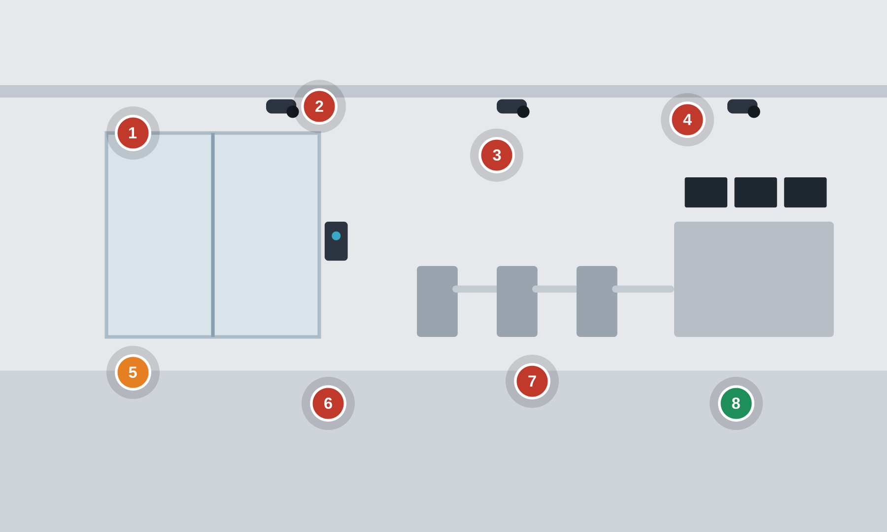
Numbered markers = planted findings. ● cyber ● safety ● good practice
Setting. A physical security system for a building or critical site. A Physical Access Control System (PACS) with IP door controllers and card readers governs badge access and electric locks; CCTV cameras feed a VMS/NVR; intrusion detection, turnstiles/mantraps and elevator access round it out. PACS is the cyber-physical gateway to substations, data-center white space and control rooms.
Key OT/IoT assets: PACS door controllers · Card / badge readers (Wiegand / OSDP) · CCTV cameras & VMS / NVR · Intrusion detection panel · Turnstiles / mantrap & elevator control · Access control server + directory
People & roles: Physical security manager · Security operations center (SOC) operator · PACS / CCTV integrator · Facilities · Employees & visitors
Processes: Badge access & authorization · Video surveillance & retention · Alarm monitoring & response · Visitor management · Credential lifecycle
What to look for
# | What to look for | Standards flagged — requirement ID & name
1 | Cleartext Wiegand readers Cyber  Readers wired Wiegand (cleartext) rather than OSDP Secure; card data can be sniffed or replayed. | 3-3 SR 3.1 Communication integrity  3-3 SR 4.3 Use of cryptography  3-3 SR 1.2 Software process and device identification and authentication
2 | Default-cred IP cameras Cyber  IP cameras / NVR on default credentials, internet-exposed or shared with IT. | 3-3 SR 1.5 Authenticator management  3-3 SR 5.2 Zone boundary protection  3-3 SR 1.13 Access via untrusted networks
3 | Flat door-controller net Cyber  Door controllers on a flat network with corporate; no segmentation. | 3-3 SR 5.1 Network segmentation  3-3 SR 5.2 Zone boundary protection  4-2 CR 5.1 Network segmentation
4 | Shared PACS admin, no audit Cyber  PACS server unpatched on a shared admin account; door commands are not attributed or audited. | 3-3 SR 1.1 Human user identification and authentication  3-3 SR 2.8 Auditable events  3-3 SR 2.12 Non-repudiation
5 | Unlock override enabled Safety  Door 'free-egress / unlock schedule' override left enabled; fail-safe vs fail-secure not managed. | PLC #2 Track operating modes  PLC #15 Define a safe process state in case of a PLC restart  3-3 SR 2.1 Authorization enforcement
6 | Unpatched, tamperable devices Cyber  Camera/reader firmware unpatched with no signed updates; devices physically accessible and tamperable. | 4-2 EDR 3.11 Physical tamper resistance and detection  4-2 EDR 3.10 Support for updates  4-2 CR 2.13 Use of physical diagnostic and test interfaces
7 | Always-on VMS/PACS access Cyber  VMS/PACS integrator remote access left permanently connected on default credentials. | 3-3 SR 1.13 Access via untrusted networks  3-3 SR 1.5 Authenticator management  3-3 SR 2.6 Remote session termination
8 | OSDP-secure, segmented, logged Good practice  GOOD PRACTICE: OSDP-secure readers, segmented PACS/VMS zone, per-user accounts with logged door commands and signed firmware. | 3-3 SR 3.1 Communication integrity  3-3 SR 2.8 Auditable events  4-2 EDR 3.14 Integrity of the boot process
Photoreal image-generation prompt
Feed this to your image tool to render a photoreal “spot-the-issue” base scene matching the corporate example.
Photorealistic shot of a corporate building secure entrance: optical turnstiles and a mantrap door, badge/card readers beside glass doors, an electric door lock, ceiling CCTV cameras, and a security desk with a video wall (VMS). Training tells: a reader with exposed cabling labelled 'Wiegand – cleartext', an NVR/camera screen 'admin/admin', an open door-controller cabinet with a laptop wired in, a monitor 'PACS remote access: always on', a note 'cameras on corp VLAN', and a side security door propped open. Realistic lobby lighting, no text overlays or annotations.
WATER & WASTEWATER Water & Wastewater — Surface Water Treatment Plant
Large plant — SCADA, Rockwell/Schneider PLCs, chlorine dosing, filtration, remote telemetry
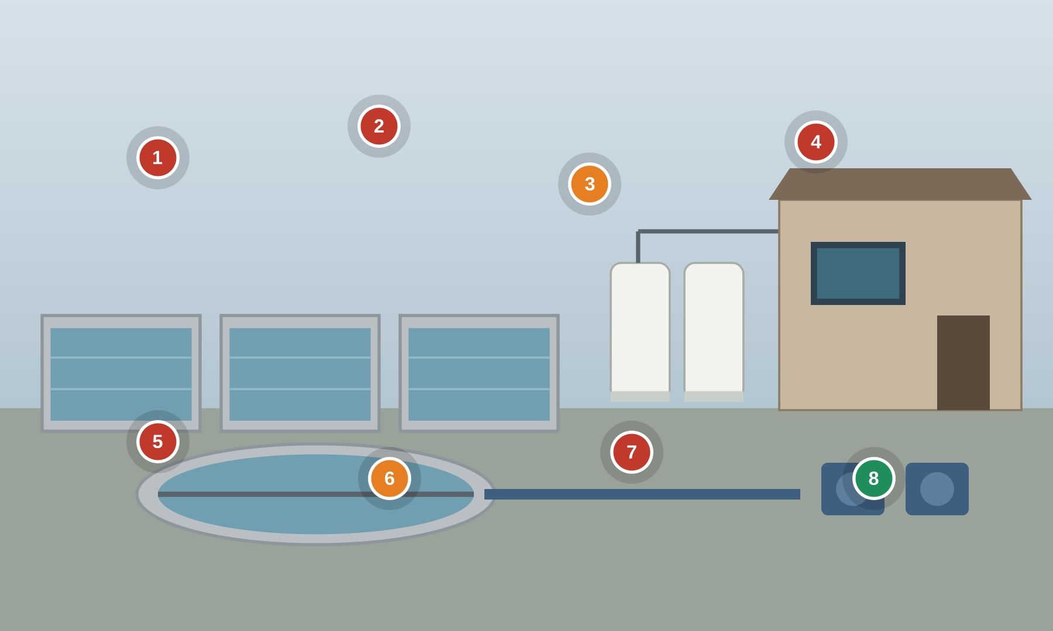
Numbered markers = planted findings. ● cyber ● safety ● good practice
Setting. A municipal surface-water treatment plant: raw-water intake, coagulation and flocculation, filtration, then chlorine disinfection into the clearwell and high-service pumps. Operators run the plant from a SCADA HMI; PLCs drive dosing pumps, valves and filter backwash.
Key OT/IoT assets: PLCs (Rockwell Allen-Bradley ControlLogix / MicroLogix, Schneider Modicon M580) · SCADA servers & HMIs (AVEVA InTouch / Inductive Automation Ignition) · Sodium-hypochlorite dosing skid & metering pumps · Chlorine & turbidity analyzers (Hach CL17 / TU5) · High-service pump VFDs · Cellular/radio telemetry to remote sites · Engineering workstation (Studio 5000 / EcoStruxure)
People & roles: Plant operator (shift) · SCADA / automation technician · Maintenance & instrument technician · Contract system integrator (remote) · Lab / compliance staff
Processes: Coagulant & chlorine dosing control · Filter backwash sequencing · SCADA alarm & setpoint management · Remote-site polling · Chemical inventory & safety
What to look for
# | What to look for | Standards flagged — requirement ID & name
1 | Internet-exposed PLC Cyber  A MicroLogix PLC is reachable from the internet through a cellular gateway with no VPN or firewall in front of it. | 3-3 SR 1.13 Access via untrusted networks  3-3 SR 5.2 Zone boundary protection  PLC #13 Disable unused / unneeded communication ports and protocols
2 | Shared SCADA login Cyber  HMI signed in with a shared 'operator' account on a default credential; no per-user identity or attribution. | 3-3 SR 1.1 Human user identification and authentication  3-3 SR 1.5 Authenticator management  4-2 CR 1.1 Human user identification and authentication
3 | Unbounded chlorine dose Safety  The HMI accepts any chlorine dose setpoint; the PLC enforces no high limit, so a bad value can overdose finished water. | PLC #8 Validate HMI input variables at the PLC level, not only at the HMI  PLC #12 Validate inputs based on physical plausibility  3-3 SR 3.5 Input validation
4 | Always-on remote access Cyber  An unattended remote-access tool is left running on the SCADA workstation with no session control. | 3-3 SR 1.13 Access via untrusted networks  3-3 SR 2.6 Remote session termination  3-3 SR 6.2 Continuous monitoring
5 | Flat IT/OT network Cyber  Business and SCADA devices share one flat subnet with no zone boundary. | 3-3 SR 5.1 Network segmentation  3-3 SR 5.2 Zone boundary protection  4-2 CR 5.1 Network segmentation
6 | Clearwell alarm inhibited Safety  The clearwell high/low-level alarm is inhibited, so operators lose warning of an unsafe level. | PLC #20 Trap false negatives and false positives for critical alerts  PLC #11 Instrument for plausibility checks  3-3 SR 6.2 Continuous monitoring
7 | No PLC backup / change log Cyber  PLC logic changes are unversioned, with no backup, no integrity check and no audit trail of who changed what. | 3-3 SR 7.3 Control system backup  3-3 SR 2.8 Auditable events  PLC #5 Use cryptographic and/or checksum integrity checks for PLC code
8 | Independent dosing interlock Good practice  GOOD PRACTICE: an independent hardwired high-chlorine interlock trips dosing to a safe state regardless of the HMI or PLC value. | PLC #12 Validate inputs based on physical plausibility  3-3 SR 3.6 Deterministic output
Photoreal image-generation prompt
Feed this to your image tool to render a photoreal “spot-the-issue” base scene matching the corporate example.
Photorealistic wide shot inside a municipal drinking-water treatment plant, rows of open rectangular filter basins and clearwell, a sodium-hypochlorite chemical dosing skid with white tanks and metering pumps, a SCADA control room visible through a window. Training tells: a SCADA HMI shows a shared login 'operator / operator' and a chlorine dose field set to an impossibly high value, an Allen-Bradley MicroLogix PLC in an open panel wired to a cellular modem with a sticky note 'public IP - no VPN', a monitor showing 'TeamViewer - always on', a Hach chlorine analyzer panel with an 'ALARM INHIBITED' tag, a network switch mixing office and SCADA cables, a laptop plugged into the PLC. Realistic industrial lighting, clean waterworks detail, no text overlays or annotations.
WATER & WASTEWATER Water & Wastewater — Remote Sewer Lift Station
Unstaffed lift station — RTU/PLC, wet-well level, cellular SCADA, pump control
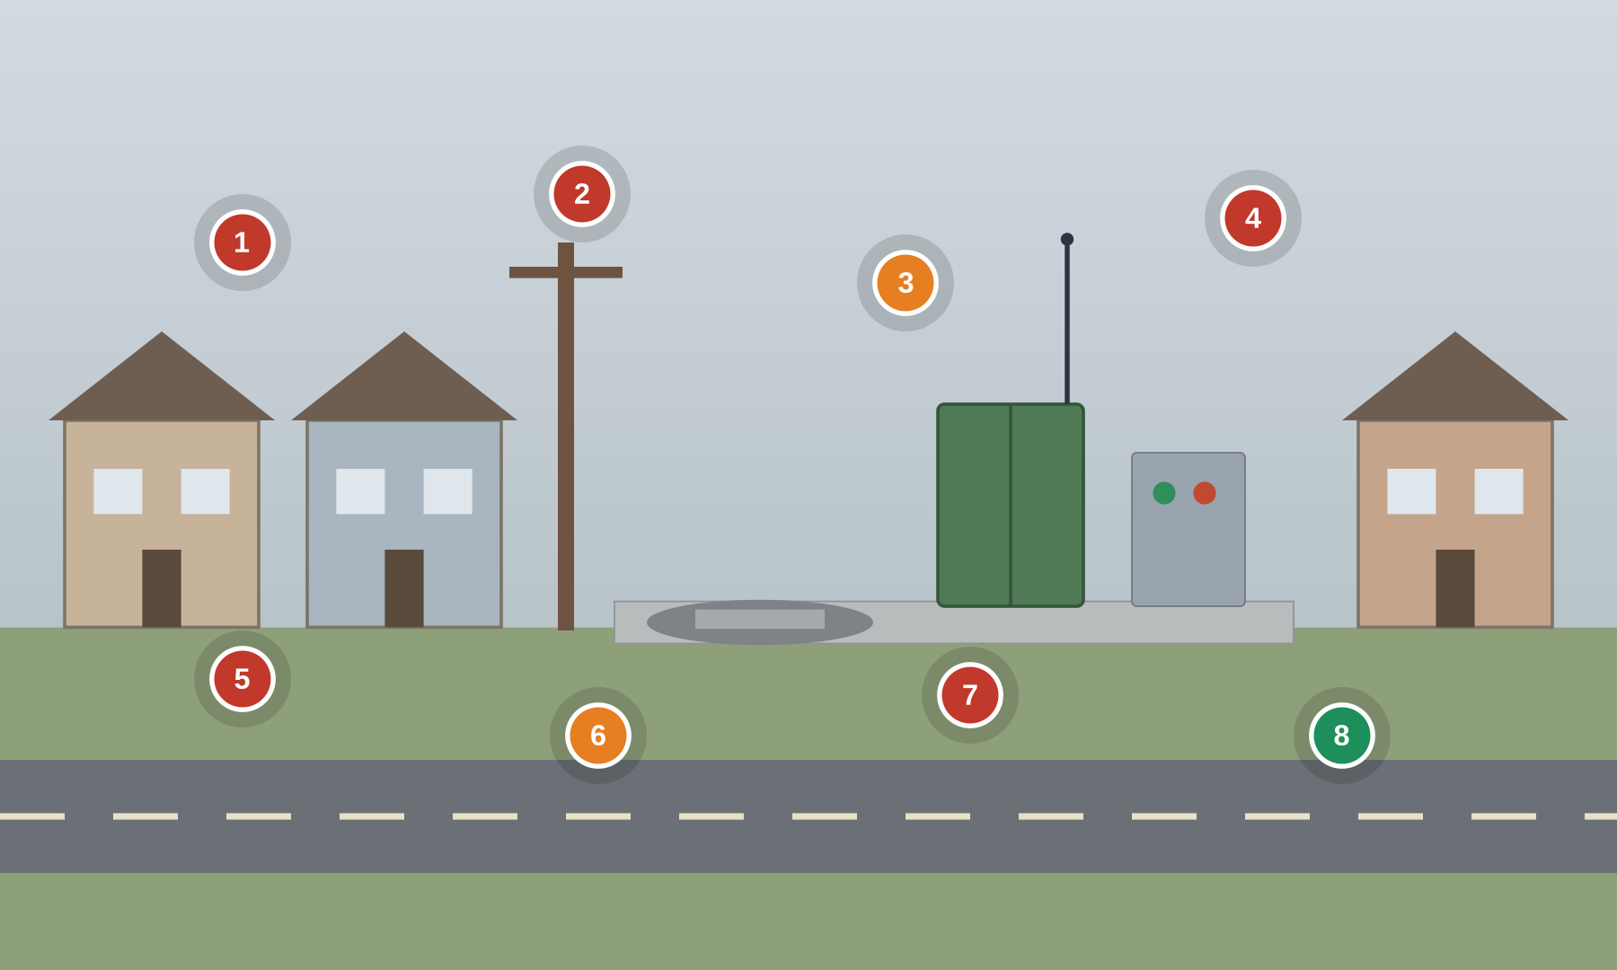
Numbered markers = planted findings. ● cyber ● safety ● good practice
Setting. An unstaffed sewage lift station: a wet well with duty/standby pumps, level sensors, and a small RTU/PLC in a roadside cabinet that reports to the utility SCADA over cellular. Overflow here spills raw sewage to the environment.
Key OT/IoT assets: Station PLC / RTU (Unitronics Vision, Mission Communications RTU) · Pump controller (Xylem Flygt MultiSmart) · Wet-well level transducer & float switches · Duty/standby pump contactors & VFDs · Cellular router (Sierra Wireless AirLink / Digi) · High-level overflow alarm · Local control panel (HOA switches)
People & roles: SCADA operator (central control room) · Collections / maintenance crew · On-call technician · Contract integrator / pump vendor service
Processes: Wet-well level & pump sequencing · High-level overflow alarming · Remote polling & dial-out alarms · Pump run-time / fault reporting · Confined-space & site access
What to look for
# | What to look for | Standards flagged — requirement ID & name
1 | Default RTU credential Cyber  The RTU/PLC still uses the vendor default PIN/password printed on a sticky note. | 3-3 SR 1.5 Authenticator management  3-3 SR 1.7 Strength of password-based authentication  4-2 CR 1.7 Strength of password-based authentication
2 | Internet-reachable RTU Cyber  The RTU is exposed directly to the internet over cellular with a public IP and no VPN. | 3-3 SR 1.13 Access via untrusted networks  3-3 SR 5.2 Zone boundary protection  PLC #13 Disable unused / unneeded communication ports and protocols
3 | High-level float bypassed Safety  The wet-well high-level overflow alarm/float is tagged into BYPASS, removing the last warning before a sanitary overflow. | PLC #7 Validate and alert for paired inputs / outputs  PLC #20 Trap false negatives and false positives for critical alerts  3-3 SR 6.2 Continuous monitoring
4 | Open cabinet, laptop wired in Cyber  The field cabinet is unlocked and an unmanaged laptop is connected to the controller's engineering port. | 4-2 CR 2.13 Use of physical diagnostic and test interfaces  3-3 SR 2.3 Use control for portable and mobile devices  4-2 EDR 3.11 Physical tamper resistance and detection
5 | Plaintext SCADA polling Cyber  Level and pump data are polled over an unauthenticated plaintext protocol that can be read or spoofed. | 3-3 SR 3.1 Communication integrity  3-3 SR 4.3 Use of cryptography  4-2 CR 3.1 Communication integrity
6 | Pump left in HAND Safety  A pump hand-off-auto switch is left in HAND, defeating automatic level control, and the mode change is not reported to SCADA. | PLC #2 Track operating modes  3-3 SR 6.2 Continuous monitoring  84.09 Operation Bypass / override management for the safety function
7 | No remote-access logging Cyber  Remote sessions to the RTU are neither alerted nor logged, so intrusions go unseen. | 3-3 SR 2.8 Auditable events  3-3 SR 6.2 Continuous monitoring  3-3 SR 2.6 Remote session termination
8 | Independent overflow alarm Good practice  GOOD PRACTICE: a separate hardwired high-high float dials out an overflow alarm independent of the RTU and SCADA path. | PLC #20 Trap false negatives and false positives for critical alerts  3-3 SR 6.2 Continuous monitoring
Photoreal image-generation prompt
Feed this to your image tool to render a photoreal “spot-the-issue” base scene matching the corporate example.
Photorealistic shot of a small remote sewage lift station at a roadside, a green metal RTU cabinet on a concrete pad with a whip cellular antenna, a wet-well hatch and pump control panel nearby, a residential street behind. Training tells: the RTU cabinet door hangs open with a Unitronics PLC exposed and a laptop wired in, a sticky note on the door reads 'SCADA: 1234 / default', a cellular router with a label 'public IP', the wet-well high-level float has a 'BYPASS' tag zip-tied to it, a pump HOA switch left in HAND, a small screen showing an internet-reachable VNC session. Overcast daylight, realistic utility detail, no text overlays or annotations.
HEALTHCARE Healthcare — Hospital Facility Control Systems
Hospital BMS — Metasys/Desigo/Niagara, isolation-room pressure, medical-gas alarms, generator/ATS
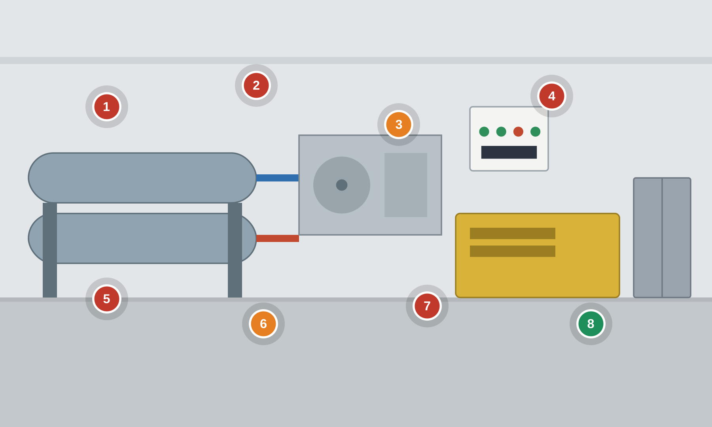
Numbered markers = planted findings. ● cyber ● safety ● good practice
Setting. The facility side of a hospital: a building management system runs chillers, air handlers and isolation-room pressure, medical-gas alarm panels warn of oxygen/vacuum faults, and an emergency generator with an automatic transfer switch backs up life-safety loads.
Key OT/IoT assets: BMS (Johnson Controls Metasys / Siemens Desigo CC / Tridium Niagara) · BACnet / Modbus field controllers · Isolation-room pressure monitors (TSI) · Medical-gas alarm panels (Amico / BeaconMedaes) · Chillers & air-handling units (Trane / York) · Emergency generator & ATS (Cummins / ASCO) · BMS operator workstation
People & roles: Facilities / plant operations engineer · BMS integrator / OEM service (remote) · Hospital IT / network team · Infection-control staff · On-call maintenance
Processes: HVAC & isolation-room pressure control · Medical-gas alarm monitoring · Emergency power transfer testing · BMS alarm & setpoint management · Change control / MOC
What to look for
# | What to look for | Standards flagged — requirement ID & name
1 | Default BMS credential Cyber  The BMS workstation and controllers use the default admin/admin credential on a sticky note. | 3-3 SR 1.5 Authenticator management  3-3 SR 1.7 Strength of password-based authentication  3-3 SR 1.1 Human user identification and authentication
2 | Internet-exposed BMS Cyber  The BMS supervisory controller is reachable from the internet for vendor convenience, with no VPN or boundary. | 3-3 SR 1.13 Access via untrusted networks  3-3 SR 5.2 Zone boundary protection  4-2 NDR 5.2 Zone boundary protection
3 | Isolation-pressure alarm off Safety  A negative-pressure isolation-room alarm is disabled, so a loss of containment would go unnoticed. | PLC #20 Trap false negatives and false positives for critical alerts  3-3 SR 6.2 Continuous monitoring  84.09 Operation Bypass / override management for the safety function
4 | Unauthenticated BACnet Cyber  BACnet writes to facility controllers require no authentication and can be spoofed on the flat network. | 3-3 SR 3.1 Communication integrity  3-3 SR 2.1 Authorization enforcement  4-2 CR 3.1 Communication integrity
5 | Flat IT/BMS network Cyber  BMS, IT and clinical networks share segments with no zone boundary between them. | 3-3 SR 5.1 Network segmentation  3-3 SR 5.2 Zone boundary protection  4-2 CR 5.1 Network segmentation
6 | Medical-gas alarm bypassed Safety  A medical-gas (oxygen/vacuum) alarm panel point is tagged into BYPASS, masking a supply fault. | PLC #7 Validate and alert for paired inputs / outputs  3-3 SR 6.2 Continuous monitoring  84.09 Operation Bypass / override management for the safety function
7 | Integrator laptop on BMS Cyber  An unmanaged integrator laptop is connected to the open BMS panel's engineering port. | 3-3 SR 2.3 Use control for portable and mobile devices  4-2 CR 2.13 Use of physical diagnostic and test interfaces  3-3 SR 3.2 Malicious code protection
8 | Tested ATS on isolated LAN Good practice  GOOD PRACTICE: the generator/ATS controls sit on a monitored, segmented LAN and emergency transfer is routinely tested and logged. | 3-3 SR 5.2 Zone boundary protection  3-3 SR 7.5 Emergency power
Photoreal image-generation prompt
Feed this to your image tool to render a photoreal “spot-the-issue” base scene matching the corporate example.
Photorealistic shot of a hospital central plant and BMS control area: large chillers and air-handling units with piping, a wall-mounted building automation panel, a medical-gas alarm annunciator panel, an emergency generator and automatic transfer switch behind glass. Training tells: a BMS operator screen shows 'Isolation Room 3 - negative pressure ALARM DISABLED', a Johnson Controls BACnet controller with its cover open and a laptop wired in, a sticky note 'BMS: admin/admin', a router labelled 'internet-exposed', a medical-gas panel with a 'BYPASS' tag, a network switch mixing IT and BMS cables. Realistic facility lighting, no text overlays or annotations.
HEALTHCARE Healthcare — ER Medical Device Systems
Emergency department — patient monitors, infusion pumps, device gateways, biomed VLAN
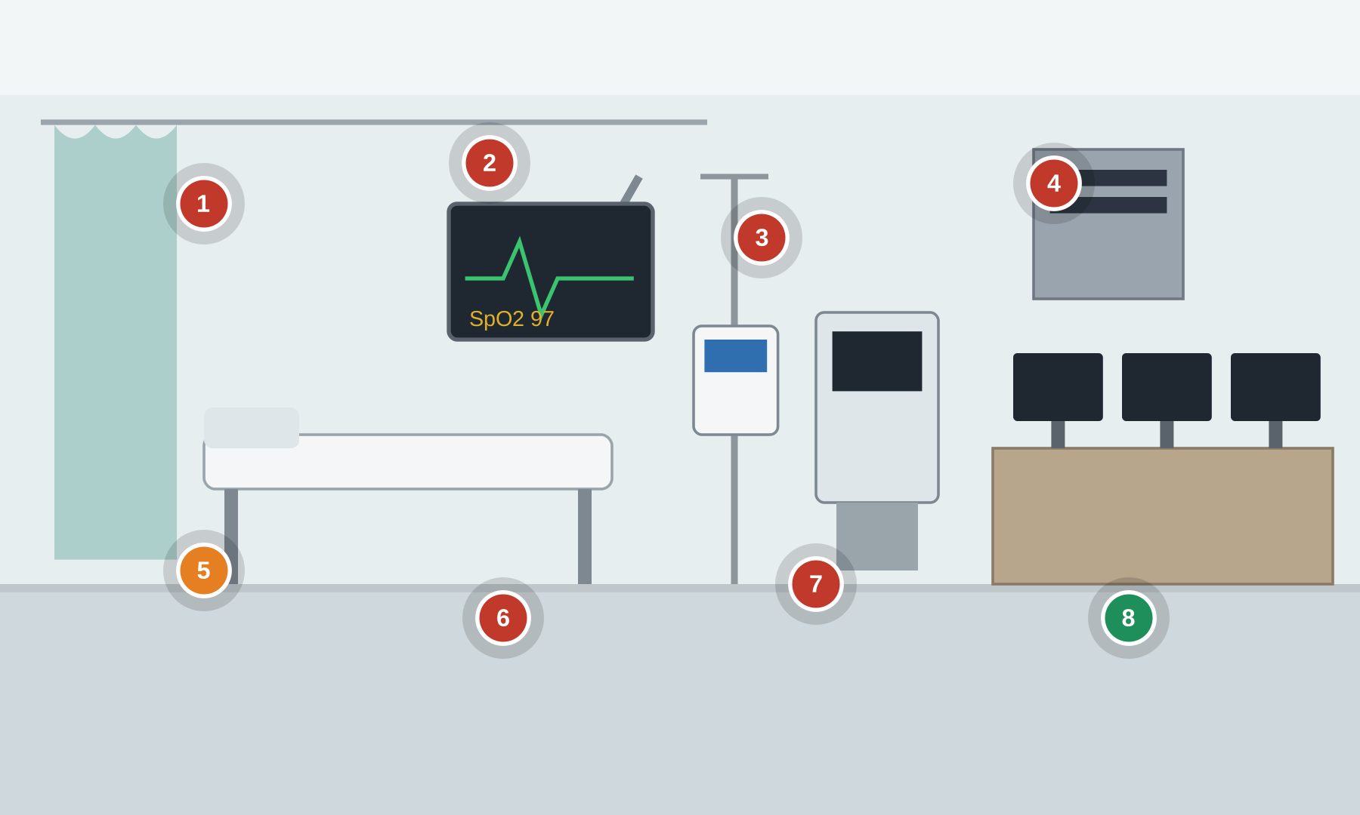
Numbered markers = planted findings. ● cyber ● safety ● good practice
Setting. An emergency department bay: networked patient monitors, infusion pumps and ventilators connect through a medical-device integration gateway to the EHR, over what should be a segmented biomedical network.
Key OT/IoT assets: Patient monitors (Philips IntelliVue / GE CARESCAPE / Mindray) · Infusion pumps (BD Alaris / Baxter / ICU Medical) · Ventilators (Hamilton / Dräger) · Device integration gateway (Philips Capsule) · Central monitoring station · Biomedical VLAN switch & Wi-Fi · Portable X-ray / PACS-DICOM endpoint
People & roles: ER nurse / clinician · Biomedical engineering (HTM) · Clinical IT / integration team · Device vendor field service (on-site & remote) · Registration / transport staff
Processes: Vitals capture & alarm routing · Infusion dose programming · Device-to-EHR integration · Firmware / recall management · Device onboarding & inventory
What to look for
# | What to look for | Standards flagged — requirement ID & name
1 | Default monitor login Cyber  A networked patient monitor ships on a default admin credential that was never changed. | 3-3 SR 1.5 Authenticator management  3-3 SR 1.1 Human user identification and authentication  4-2 CR 1.1 Human user identification and authentication
2 | Exposed pump service port Cyber  An infusion pump's diagnostic/service port is physically exposed and used to load firmware from an uncontrolled USB stick. | 4-2 CR 2.13 Use of physical diagnostic and test interfaces  4-2 EDR 3.11 Physical tamper resistance and detection  3-3 SR 3.2 Malicious code protection
3 | Unsigned device firmware Cyber  Medical-device firmware is updated with no signature or integrity check on the image. | 4-2 EDR 3.10 Support for updates  4-2 EDR 3.14 Integrity of the boot process  3-3 SR 3.4 Software and information integrity
4 | Flat biomed/guest VLAN Cyber  Biomedical devices share a flat VLAN with guest Wi-Fi and general IT, with no zone boundary. | 3-3 SR 5.1 Network segmentation  3-3 SR 5.2 Zone boundary protection  4-2 NDR 5.2 Zone boundary protection
5 | Device alarms paused Safety  Alarms at the central monitoring station are left globally paused, so a deteriorating patient may not be flagged. | PLC #20 Trap false negatives and false positives for critical alerts  3-3 SR 6.2 Continuous monitoring  84.09 Operation Bypass / override management for the safety function
6 | Unencrypted device data Cyber  Vitals and device data traverse the network in plaintext and can be read or altered in transit. | 3-3 SR 3.1 Communication integrity  3-3 SR 4.3 Use of cryptography  3-3 SR 4.1 Information confidentiality
7 | Unsupported legacy OS Cyber  A device runs an end-of-support operating system that can no longer be patched. | 4-2 HDR 3.10 Support for updates  3-3 SR 7.8 Control system component inventory
8 | Segmented, inventoried devices Good practice  GOOD PRACTICE: critical devices sit on a monitored, segmented biomedical zone with a maintained device inventory. | 3-3 SR 5.2 Zone boundary protection  3-3 SR 7.8 Control system component inventory
Photoreal image-generation prompt
Feed this to your image tool to render a photoreal “spot-the-issue” base scene matching the corporate example.
Photorealistic shot of a hospital emergency department bay, a patient monitor on a wall arm, an infusion pump on a pole, a ventilator, and a mobile computer cart. Training tells: a patient monitor screen shows a default login banner 'admin/admin', an infusion pump with a service port exposed and a USB stick labelled 'firmware', a central station monitor showing 'device alarms - paused', a biomedical network switch in an open wall cabinet sharing cables with guest Wi-Fi, a sticky note on the cart 'VLAN: flat - biomed+guest', a legacy monitor labelled 'Windows - end of support'. Realistic clinical lighting, no identifiable patient, no text overlays or annotations.
AVIATION Aviation — Airfield Lighting Control System
ALCMS — constant-current regulators, series lighting circuits, runway/taxiway control
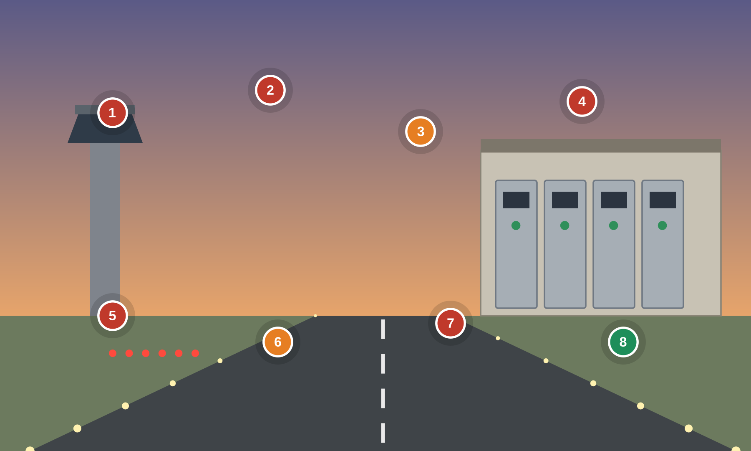
Numbered markers = planted findings. ● cyber ● safety ● good practice
Setting. An airfield lighting vault and tower: an Airfield Lighting Control & Monitoring System (ALCMS) drives constant-current regulators (CCRs) that power runway, taxiway and approach lighting series circuits, commanded from the tower.
Key OT/IoT assets: ALCMS servers & HMI (ADB SAFEGATE) · Constant-current regulators (ADB SAFEGATE / Liberty Airport Systems) · Vault PLCs & remote I/O · Individual lamp control & monitoring · Tower lighting control panel / touchscreen · Vault network switches & fiber to tower · Engineering workstation
People & roles: Air traffic controller (tower) · Airfield electrician · ALCMS vendor / integrator (remote support) · Airport operations · Airport IT / network team
Processes: Runway/taxiway lighting selection & intensity · Stop-bar & approach lighting control · Circuit fault monitoring · NOTAM / maintenance coordination · Change control
What to look for
# | What to look for | Standards flagged — requirement ID & name
1 | Shared ALCMS login Cyber  The lighting control HMI uses a single shared operator account; lighting commands can't be attributed. | 3-3 SR 1.1 Human user identification and authentication  3-3 SR 1.5 Authenticator management  3-3 SR 2.1 Authorization enforcement
2 | Always-on remote support Cyber  A vendor remote-support link into the ALCMS is left permanently connected with no session control. | 3-3 SR 1.13 Access via untrusted networks  3-3 SR 2.6 Remote session termination  3-3 SR 6.2 Continuous monitoring
3 | Stop-bar override on Safety  A stop-bar override is left active, defeating a runway-incursion safeguard that keeps aircraft from crossing. | PLC #2 Track operating modes  84.09 Operation Bypass / override management for the safety function  PLC #15 Define a safe process state in case of a PLC restart
4 | Flat airfield/IT network Cyber  Airfield lighting controls share a flat network with airport business IT, with no zone boundary. | 3-3 SR 5.1 Network segmentation  3-3 SR 5.2 Zone boundary protection  4-2 CR 5.1 Network segmentation
5 | Laptop on open CCR Cyber  An unmanaged laptop is wired into an open constant-current regulator cabinet's engineering port. | 4-2 CR 2.13 Use of physical diagnostic and test interfaces  3-3 SR 2.3 Use control for portable and mobile devices  4-2 EDR 3.11 Physical tamper resistance and detection
6 | Circuit-fault alarm off Safety  The lighting circuit-fault alarm is disabled, so a failed runway/taxiway circuit would not be annunciated. | PLC #20 Trap false negatives and false positives for critical alerts  3-3 SR 6.2 Continuous monitoring  PLC #7 Validate and alert for paired inputs / outputs
7 | Unauthenticated commands Cyber  Lighting selection and intensity commands cross the network unauthenticated and could be spoofed. | 3-3 SR 3.1 Communication integrity  3-3 SR 2.1 Authorization enforcement  4-2 CR 3.1 Communication integrity
8 | Segmented, monitored vault Good practice  GOOD PRACTICE: the ALCMS sits in its own monitored, segmented zone with alarming on unexpected commands. | 3-3 SR 5.2 Zone boundary protection  3-3 SR 6.2 Continuous monitoring
Photoreal image-generation prompt
Feed this to your image tool to render a photoreal “spot-the-issue” base scene matching the corporate example.
Photorealistic shot inside an airport airfield lighting vault, rows of tall constant-current regulator cabinets (ADB SAFEGATE) with an ALCMS control panel, series lighting circuit terminals, a window toward a runway with edge lights at dusk. Training tells: an ALCMS HMI shows a shared login banner and 'stop-bar override - ON', a CCR cabinet open with a laptop wired in, a sticky note 'ALCMS: operator/operator', a network switch mixing admin IT and airfield cables, a modem labelled 'remote support - always on', a panel reading 'circuit fault alarm - DISABLED'. Dusk lighting through the window, realistic airport detail, no text overlays or annotations.
AVIATION Aviation — Baggage Handling Control System
BHS — Siemens/Rockwell PLCs, Vanderlande/BEUMER sortation, EDS screening interface, conveyors
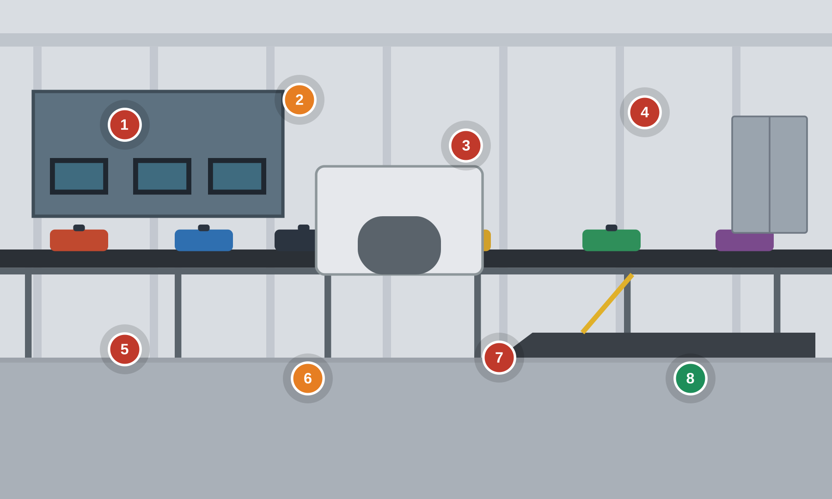
Numbered markers = planted findings. ● cyber ● safety ● good practice
Setting. An airport baggage handling system: PLC-controlled conveyors and sorters route bags from check-in through security (EDS) screening to make-up carousels, coordinated by a sortation SCADA/warehouse-control layer.
Key OT/IoT assets: BHS PLCs (Siemens S7-1500 / Rockwell ControlLogix) · Sortation SCADA / controls (Vanderlande / BEUMER / Siemens Logistics) · EDS screening (Smiths Detection CTX / Leidos) · ATR barcode / RFID arrays & diverters · Conveyor drives (SEW-Eurodrive / Siemens) · MCP-room HMIs · BHS network switches
People & roles: BHS control-room operator · Airline / ground-handler baggage staff · TSA screening staff · BHS integrator (remote & on-site) · Maintenance technician
Processes: Bag routing & sortation logic · EDS screening result handshake · Jam / fault handling & e-stops · Throughput monitoring · Change control / commissioning
What to look for
# | What to look for | Standards flagged — requirement ID & name
1 | Shared BHS HMI login Cyber  The sortation HMI uses a shared admin account; routing changes can't be attributed. | 3-3 SR 1.1 Human user identification and authentication  3-3 SR 1.5 Authenticator management  4-2 CR 1.1 Human user identification and authentication
2 | EDS interlock bypassed Safety  The explosive-detection screening interlock is in BYPASS, letting bags route to make-up without a screening result. | 3-3 SR 2.1 Authorization enforcement  84.09 Operation Bypass / override management for the safety function  PLC #2 Track operating modes
3 | PLC laptop + USB Cyber  An unmanaged laptop and USB drive are plugged into an open BHS PLC cabinet. | 4-2 CR 2.13 Use of physical diagnostic and test interfaces  3-3 SR 2.3 Use control for portable and mobile devices  3-3 SR 3.2 Malicious code protection
4 | Flat BHS/IT network Cyber  BHS controls and airport business IT share a flat network with no zone boundary. | 3-3 SR 5.1 Network segmentation  3-3 SR 5.2 Zone boundary protection  4-2 CR 5.1 Network segmentation
5 | Always-on OEM remote Cyber  The integrator's remote-maintenance link is left permanently connected into the BHS. | 3-3 SR 1.13 Access via untrusted networks  3-3 SR 2.6 Remote session termination  3-3 SR 6.2 Continuous monitoring
6 | Conveyor e-stop disabled Safety  A conveyor emergency-stop is tagged DISABLED, removing a personnel and jam safeguard. | PLC #7 Validate and alert for paired inputs / outputs  84.09 Operation Bypass / override management for the safety function  PLC #15 Define a safe process state in case of a PLC restart
7 | Unsigned PLC logic Cyber  BHS PLC programs carry no integrity check, so altered routing logic would not be detected. | PLC #5 Use cryptographic and/or checksum integrity checks for PLC code  3-3 SR 3.4 Software and information integrity  3-3 SR 2.8 Auditable events
8 | Screening handshake enforced Good practice  GOOD PRACTICE: the PLC enforces a positive EDS screening handshake before a bag can route to make-up, and logs overrides. | PLC #7 Validate and alert for paired inputs / outputs  3-3 SR 2.1 Authorization enforcement
Photoreal image-generation prompt
Feed this to your image tool to render a photoreal “spot-the-issue” base scene matching the corporate example.
Photorealistic wide shot of an airport baggage handling hall, long conveyor lines and a high-speed sorter routing suitcases, barcode scanner arrays and diverters, a controls room with HMIs behind glass. Training tells: a sortation SCADA HMI shows a shared login and 'EDS screening interlock - BYPASS', a Siemens PLC cabinet open with a laptop and USB drive, a sticky note 'HMI: admin/admin', a network switch mixing office IT and BHS cables, a modem labelled 'OEM remote - always on', a conveyor e-stop panel with a 'DISABLED' tag. Industrial hall lighting, realistic airport detail, no text overlays or annotations.
FOOD RETAIL Food Retail — Grocery Refrigeration & Cooling
Supermarket refrigeration — Copeland/Danfoss rack controllers, Carel case controls, defrost, remote monitoring
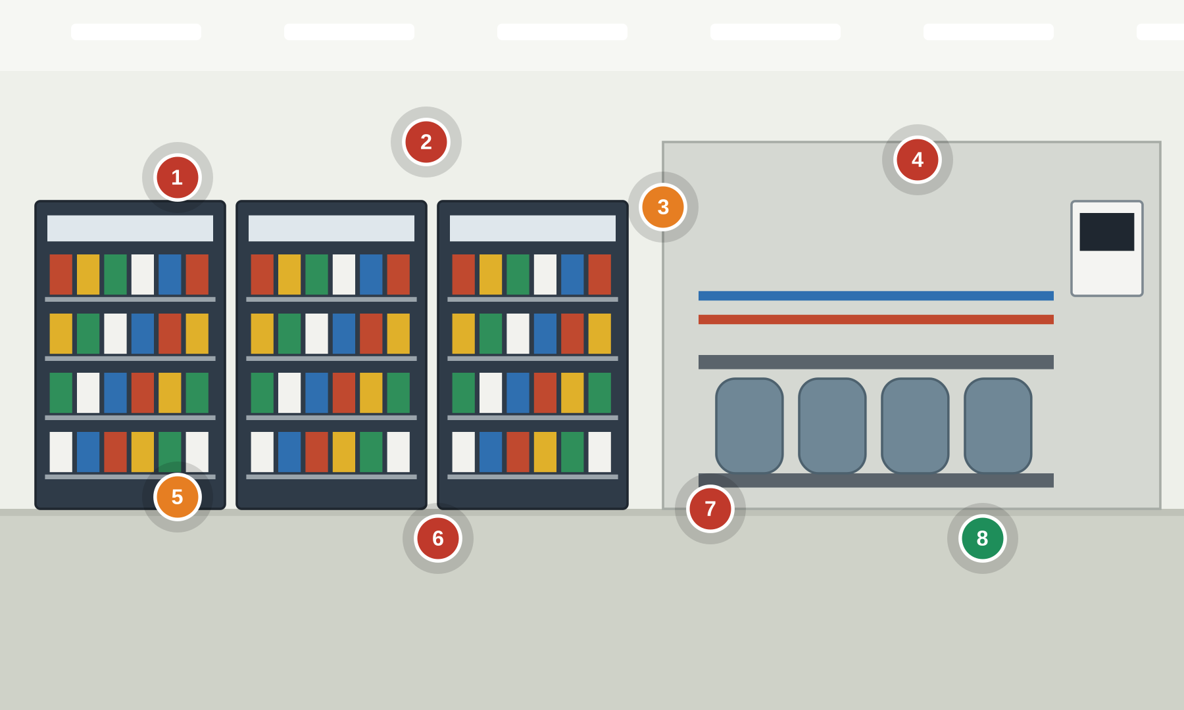
Numbered markers = planted findings. ● cyber ● safety ● good practice
Setting. A supermarket's refrigeration plant: a refrigeration rack controller manages compressors, display cases and walk-in coolers with scheduled defrost, monitored remotely by a maintenance contractor. Loss of control spoils food and can overheat equipment.
Key OT/IoT assets: Rack supervisory controller (Copeland E2/E3 / Danfoss AK-SM 800) · Case & walk-in controllers (Carel MPXpro / Danfoss AK-CC) · Display cases (Hussmann / Hillphoenix) · Compressor rack & condensers · Defrost heaters & electronic expansion valves · Refrigerant leak detection · Remote monitoring gateway / contractor portal
People & roles: Store manager / facilities · Refrigeration service contractor (remote) · Store associates · Energy-management provider · Corporate facilities / food-safety team
Processes: Case temperature & defrost control · Compressor staging · Remote monitoring & alarms · Setpoint & schedule management · Food-safety temperature logging
What to look for
# | What to look for | Standards flagged — requirement ID & name
1 | Internet-exposed controller Cyber  The refrigeration rack controller's web interface is reachable from the internet with no VPN in front of it. | 3-3 SR 1.13 Access via untrusted networks  3-3 SR 5.2 Zone boundary protection  4-2 NDR 5.2 Zone boundary protection
2 | Default controller login Cyber  The controller and remote portal use the default admin credential printed on a sticky note. | 3-3 SR 1.5 Authenticator management  3-3 SR 1.7 Strength of password-based authentication  4-2 CR 1.1 Human user identification and authentication
3 | Forced defrost abuse Safety  Defrost is forced on all cases at once, driving case temperatures up to spoilage and overheating defrost heaters. | PLC #2 Track operating modes  PLC #12 Validate inputs based on physical plausibility  3-3 SR 3.5 Input validation
4 | Always-on remote access Cyber  The maintenance contractor's remote access is left permanently connected with no session control. | 3-3 SR 1.13 Access via untrusted networks  3-3 SR 2.6 Remote session termination  3-3 SR 6.2 Continuous monitoring
5 | High-temp alarm muted Safety  Case high-temperature alarms are muted, so a spoilage/overheat condition isn't escalated. | PLC #20 Trap false negatives and false positives for critical alerts  3-3 SR 6.2 Continuous monitoring  PLC #11 Instrument for plausibility checks
6 | Unsupported firmware Cyber  The controller runs outdated firmware that is never updated, and nobody tracks what version is installed. | 4-2 EDR 3.10 Support for updates  3-3 SR 3.4 Software and information integrity  3-3 SR 7.8 Control system component inventory
7 | Laptop on controller Cyber  An unmanaged laptop is wired into the refrigeration controller's service port. | 4-2 CR 2.13 Use of physical diagnostic and test interfaces  3-3 SR 2.3 Use control for portable and mobile devices  3-3 SR 3.2 Malicious code protection
8 | Setpoint limits + alarming Good practice  GOOD PRACTICE: the controller enforces temperature/defrost limits and sends independent food-safety high-temp alarms to staff. | PLC #12 Validate inputs based on physical plausibility  3-3 SR 6.2 Continuous monitoring
Photoreal image-generation prompt
Feed this to your image tool to render a photoreal “spot-the-issue” base scene matching the corporate example.
Photorealistic shot of a supermarket refrigeration machine room and adjacent display-case aisle, a compressor rack with piping and a wall-mounted refrigeration controller, open multideck chiller cases in the aisle. Training tells: the refrigeration controller screen (Danfoss AK-SM 800) shows a case temperature climbing and 'FORCED DEFROST - all cases', a sticky note 'controller: admin/admin', a gateway labelled 'internet-exposed - no VPN', a laptop wired into the controller, a monitor showing 'remote access: maintenance - always on', a case display reading '+40C' with an 'ALARM MUTED' tag. Realistic retail/industrial lighting, no text overlays or annotations.
FOOD RETAIL Food Retail — Grocery Logistics & Facilities
Distribution center — Frick ammonia controls, Intelligrated/Dematic sortation, docks, BAS
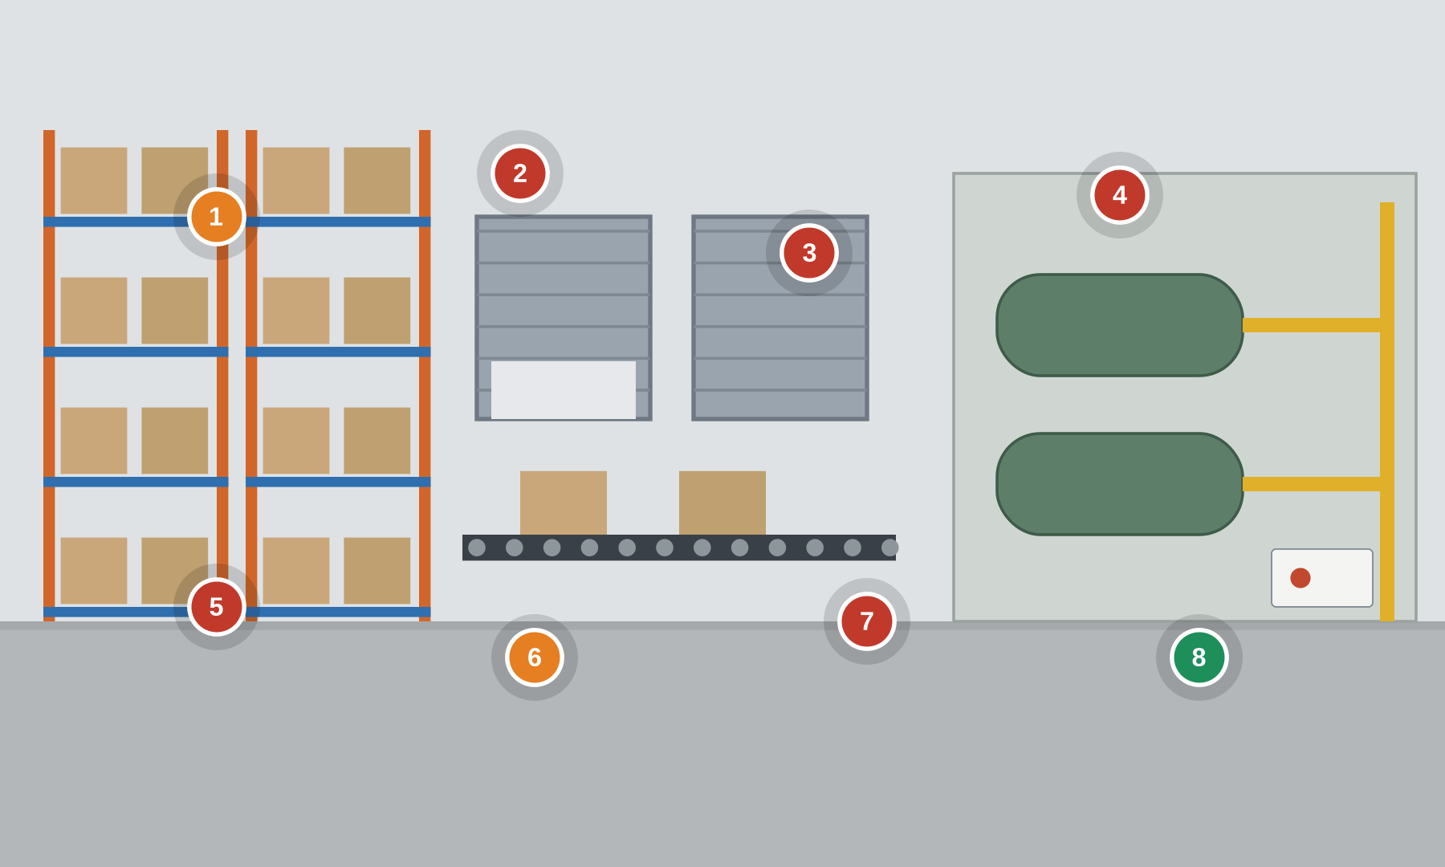
Numbered markers = planted findings. ● cyber ● safety ● good practice
Setting. A grocery distribution center: an industrial ammonia refrigeration plant cools frozen and chilled storage, PLC-driven conveyors and sorters move pallets and totes, and a building automation system runs docks, HVAC and energy. Loss of control threatens cold chain, equipment and personnel.
Key OT/IoT assets: Ammonia (NH3) refrigeration controls (Frick Quantum HD / Johnson Controls) · NH3 leak detection & ventilation · Conveyor / sortation (Honeywell Intelligrated / Dematic) on Allen-Bradley PLCs · Dock doors & levelers (Rite-Hite / Blue Giant) · BAS / energy management (Novar / Honeywell) · Cold-chain IoT temperature sensors · WMS interface & controls network switches
People & roles: DC refrigeration operator · Warehouse controls technician · Logistics / operations staff · Refrigeration & conveyor integrators (remote) · Ammonia PSM / safety coordinator
Processes: Ammonia refrigeration & defrost control · Conveyor/sortation routing · Cold-chain temperature logging · Dock scheduling & door control · Ammonia safety (PSM) & leak detection
What to look for
# | What to look for | Standards flagged — requirement ID & name
1 | Ammonia leak alarm off Safety  The NH3 refrigeration leak-detection alarm is disabled, removing warning of a toxic/flammable release. | PLC #20 Trap false negatives and false positives for critical alerts  3-3 SR 6.2 Continuous monitoring  84.09 Operation Bypass / override management for the safety function
2 | Default controls login Cyber  Refrigeration and conveyor controllers use the default admin credential on a sticky note. | 3-3 SR 1.5 Authenticator management  3-3 SR 1.7 Strength of password-based authentication  3-3 SR 1.1 Human user identification and authentication
3 | Internet-exposed BAS Cyber  The BAS/energy gateway is reachable from the internet with no VPN or boundary. | 3-3 SR 1.13 Access via untrusted networks  3-3 SR 5.2 Zone boundary protection  4-2 NDR 5.2 Zone boundary protection
4 | Flat controls/IT network Cyber  Refrigeration, conveyor and office IT share a flat network with no zone boundary. | 3-3 SR 5.1 Network segmentation  3-3 SR 5.2 Zone boundary protection  4-2 CR 5.1 Network segmentation
5 | Laptop + USB on PLC Cyber  An unmanaged laptop and USB drive are connected to open refrigeration/conveyor PLC cabinets. | 4-2 CR 2.13 Use of physical diagnostic and test interfaces  3-3 SR 2.3 Use control for portable and mobile devices  3-3 SR 3.2 Malicious code protection
6 | Dock e-stop bypassed Safety  A conveyor/dock emergency-stop is tagged into BYPASS, defeating a personnel safeguard. | PLC #7 Validate and alert for paired inputs / outputs  84.09 Operation Bypass / override management for the safety function  PLC #15 Define a safe process state in case of a PLC restart
7 | No controls monitoring Cyber  Controls-network traffic and logins are not monitored, so intrusions and changes go unseen. | 3-3 SR 6.2 Continuous monitoring  3-3 SR 2.8 Auditable events  3-3 SR 7.8 Control system component inventory
8 | Independent NH3 safety Good practice  GOOD PRACTICE: ammonia leak detection and e-stops are hardwired to an independent safety system that trips regardless of the controls network. | PLC #15 Define a safe process state in case of a PLC restart  84.09 Realization SIS zones and conduits (SIS as a separate zone)
Photoreal image-generation prompt
Feed this to your image tool to render a photoreal “spot-the-issue” base scene matching the corporate example.
Photorealistic wide shot of a grocery distribution center: an industrial ammonia refrigeration machine room with large compressors and piping on one side, and a high-bay freezer warehouse with pallet conveyors and a sorter on the other, loading docks in the background. Training tells: a refrigeration control screen shows 'NH3 leak detection - ALARM DISABLED', a compressor control panel open with a laptop wired in, a sticky note 'controls: admin/admin', a conveyor PLC cabinet with a USB drive, a network switch mixing office IT and controls cables, a BAS gateway labelled 'internet-exposed', a dock panel with an e-stop 'BYPASS' tag. Industrial warehouse lighting, realistic cold-storage detail, no text overlays or annotations.

